**General tips for the Task below.**

**Task Title**

**S3, R-53 and CDN**-

**Objective**

Worked on pre-requisite, as I watched the S3-AWS video posted in DevOps group in slack and task to work on S3, R-53 and CDN

**Prerequisites**

**List all requirements before starting**:  
• VPC Peering in cross-regions  
• Purchase domain from GoDaddy  
• Deploy static website  
• 1 CDN and 1 SSL Certificate

**Issues Faced** Briefly mention issues and how you fixed them. **Posted below in the last.**

**Conclusion**

Write 1–2 lines summarizing that the task was successfully completed.

**Task**

1. **Configure VPC peering in cross regions.**

* Created **new VPC in N. Virginia region (us-east-1)** with a CIDR range- **10.0.0.0/24**

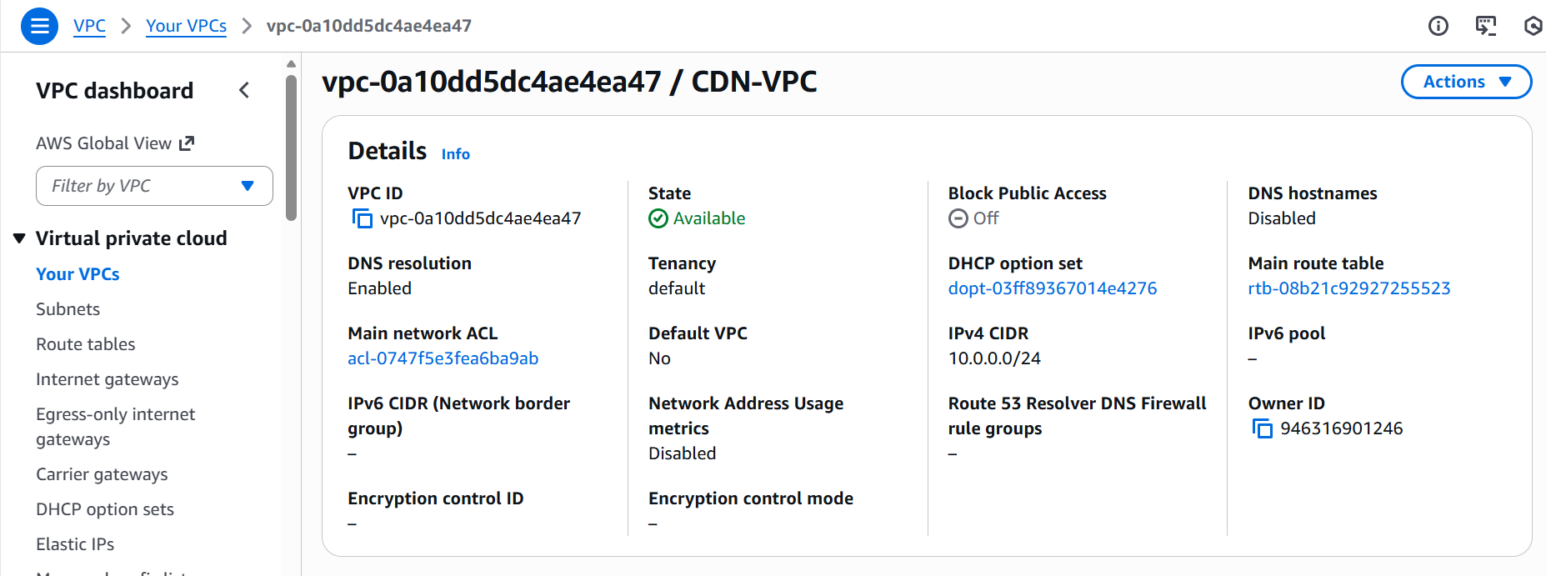

* Created new **public subnet** with a **range- 10.0.0.0/28.**

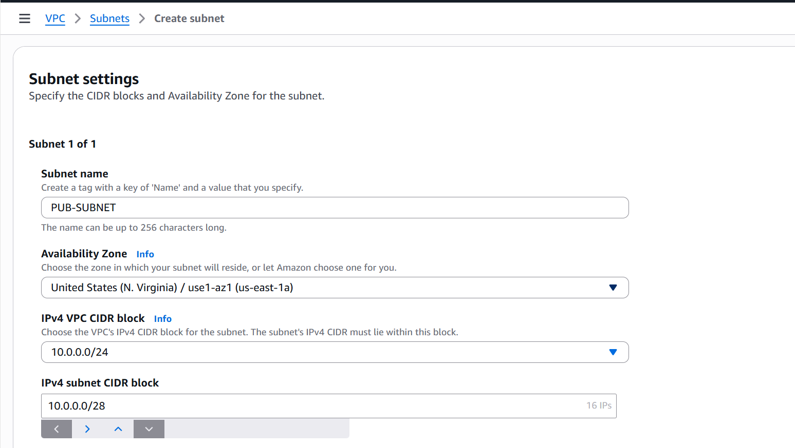

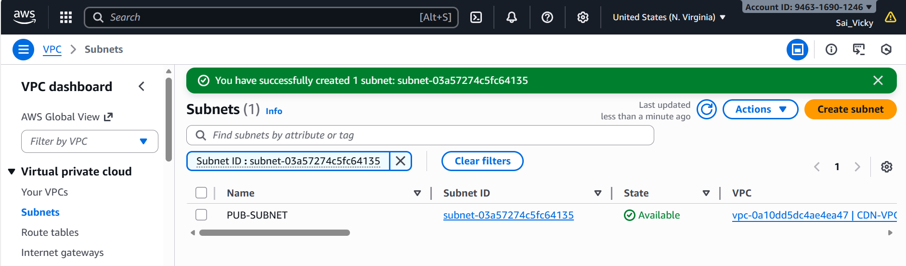

* Created a new **Internet Gateway (IGW)**, so in the next step, we can attach it to the VPC created.

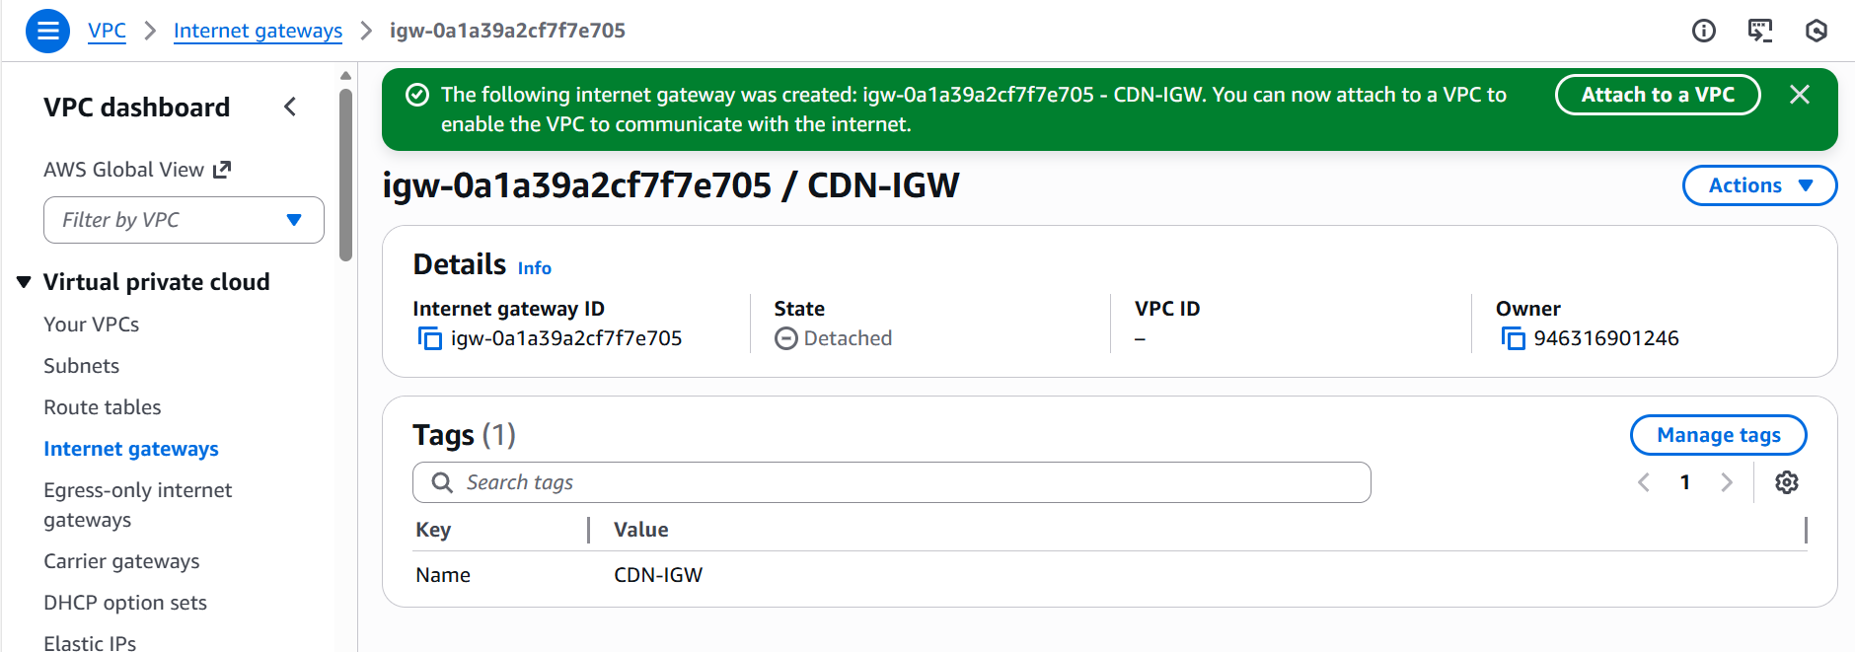

* Attached the **IGW** to the **VPC** created.

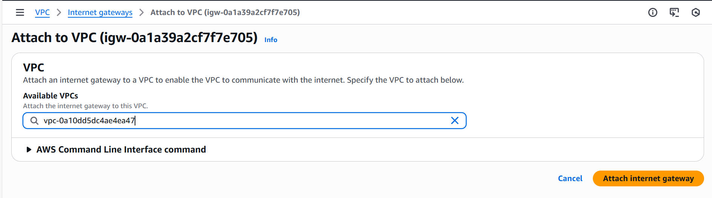

* Edited the **route tables** to include an **Internet Gateway** and attached the **IGW created.**

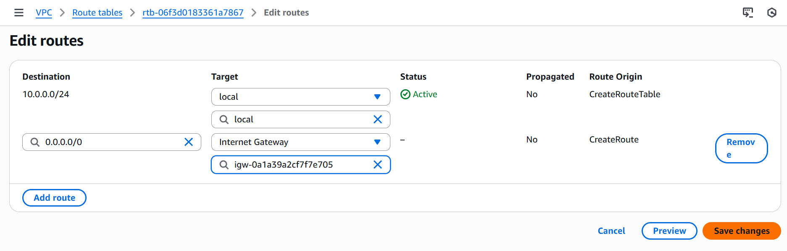

* Selected the **subnet** in the **Subnet association** and saved.

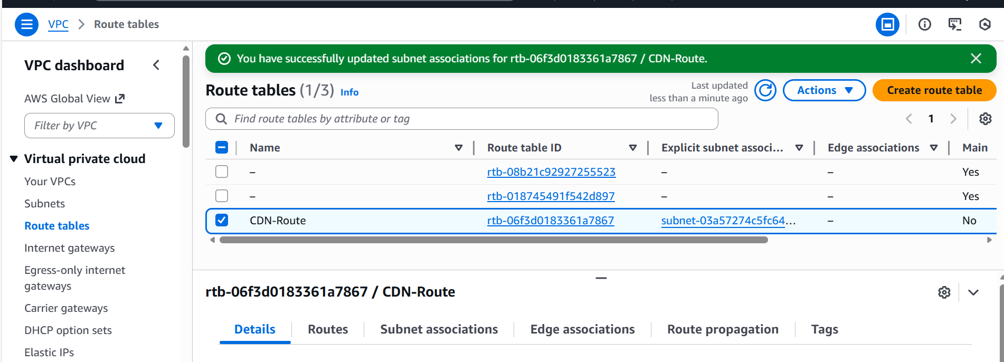

**2nd Region configurations below**

* Created a new **VPC** in the second region**- Asia Pacific (Hyderabad)** with a CIDR range- **10.0.1.0/24**

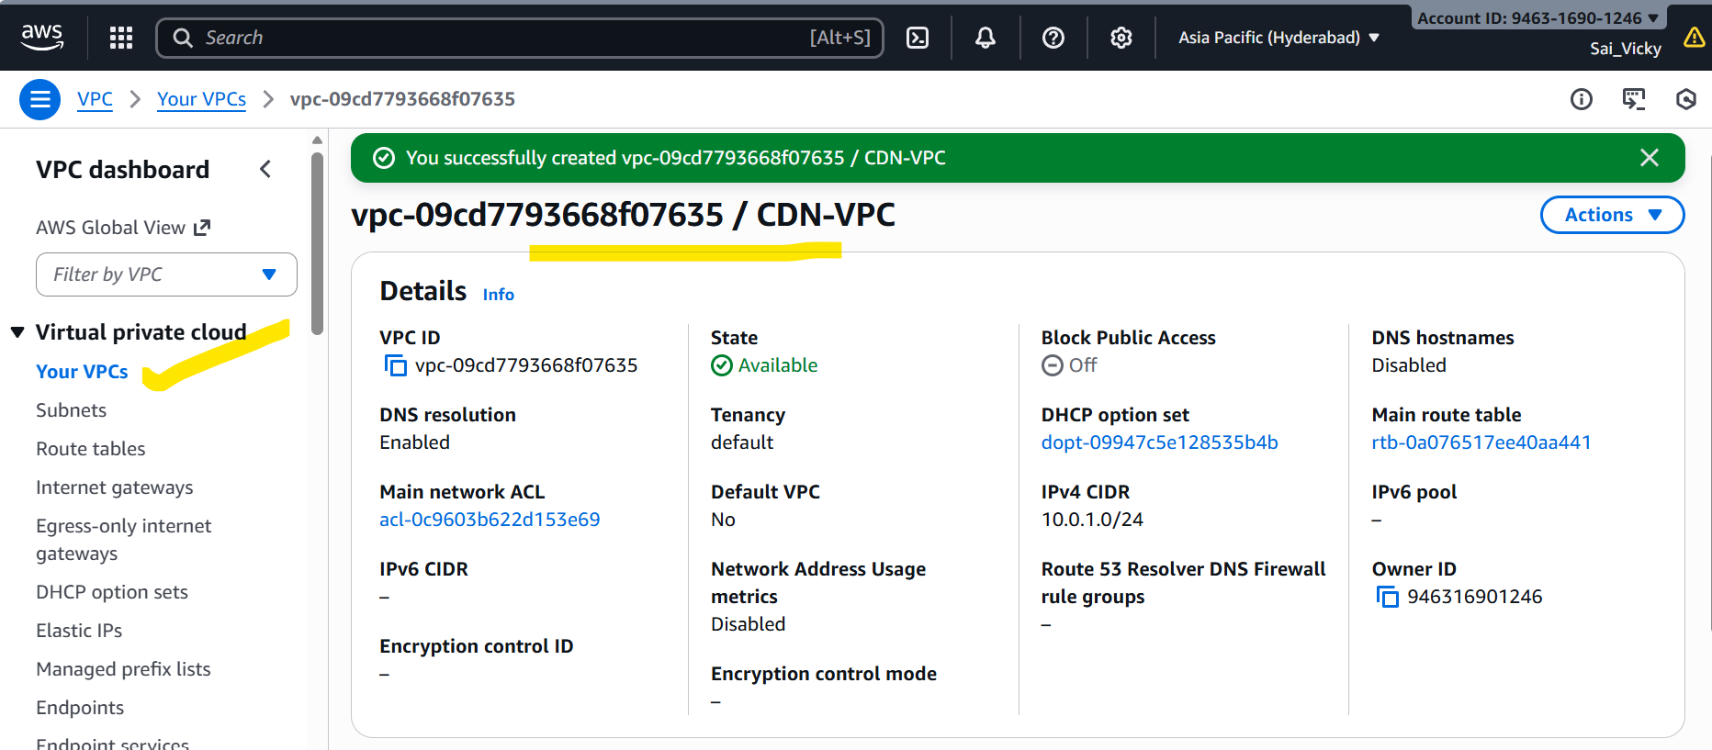

* Created new **public subnet** in **Asia Pacific** region with a CIDR-10.0.1.0/28

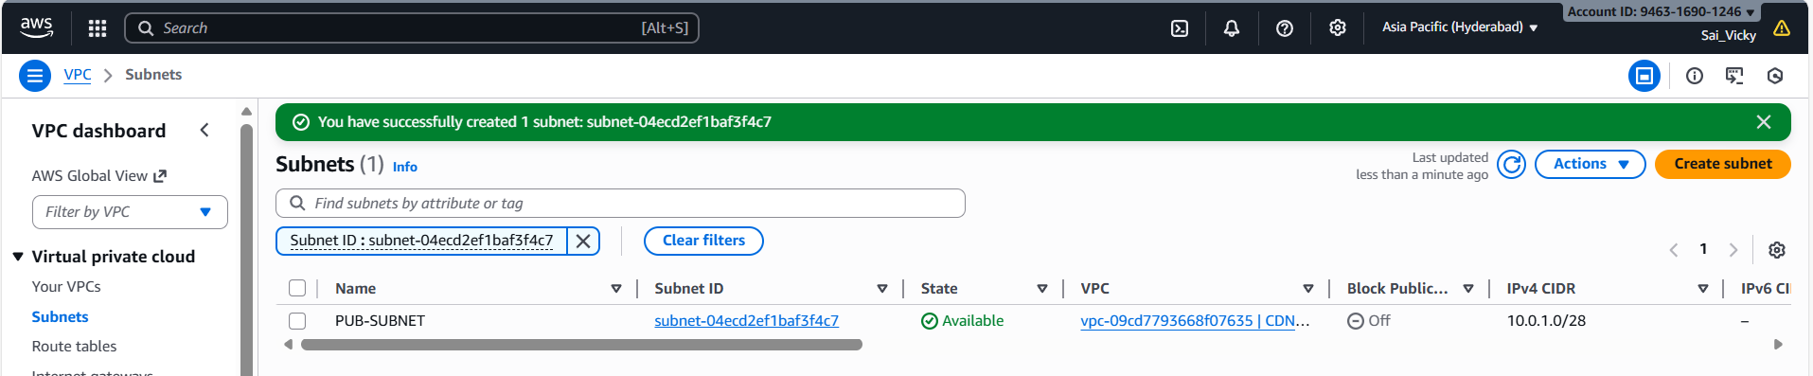

* Created a **new IGW** in the region.

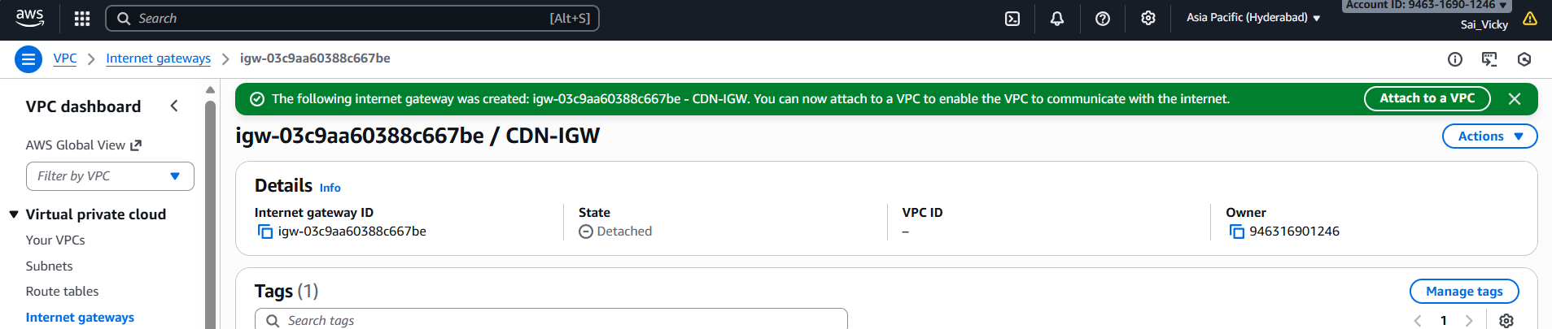

* Created a new **route table** with the **VPC** attached.

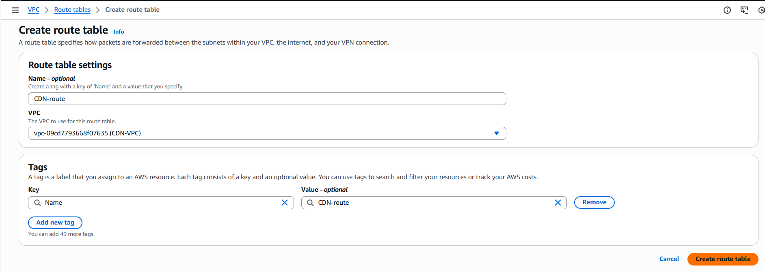

* Edited the **route table** to include **IGW** and updated the table with created **IGW.**

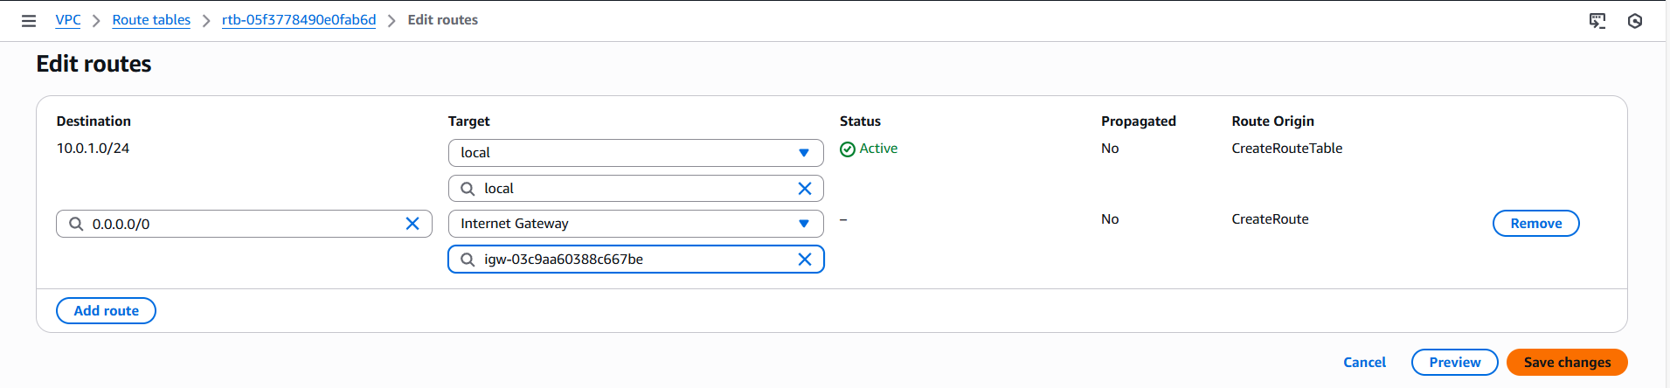

**Peering connections**

Let’s start with **creating peering connections** from **1st Region - N. Virginia- us-east-1**

* Created a new Peering connection from N. Virginia and provided acceptor region- Hyderabad.

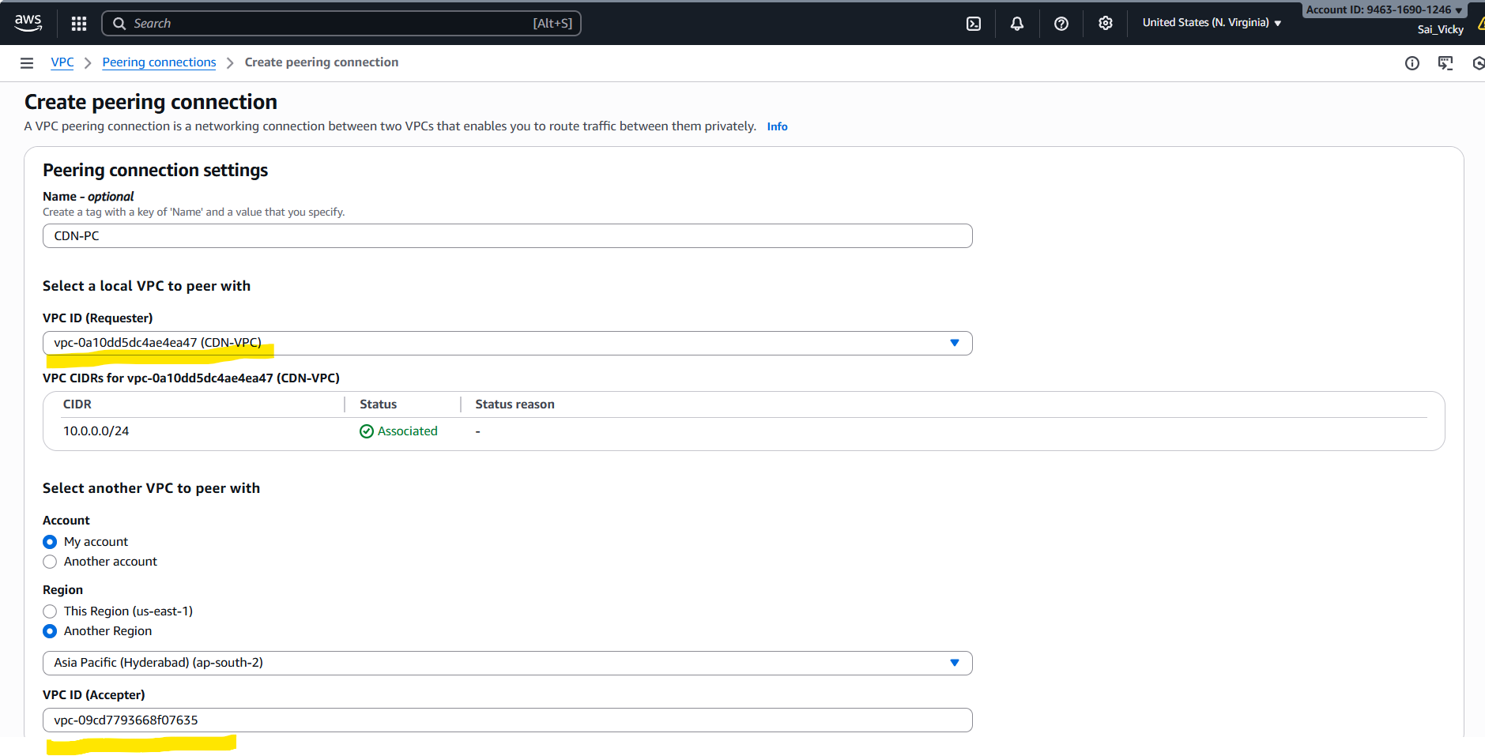

* Now, lets accept in the **Hyderabad region** as per below screenshot**.**

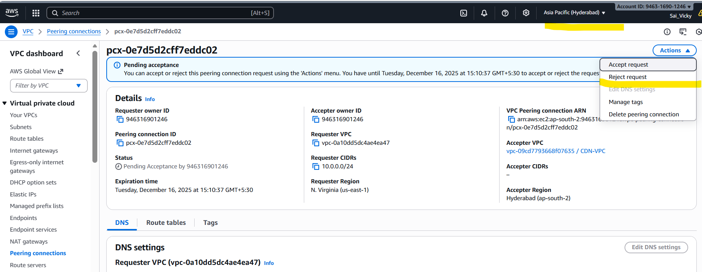

* **Now the service is active in both regions.**

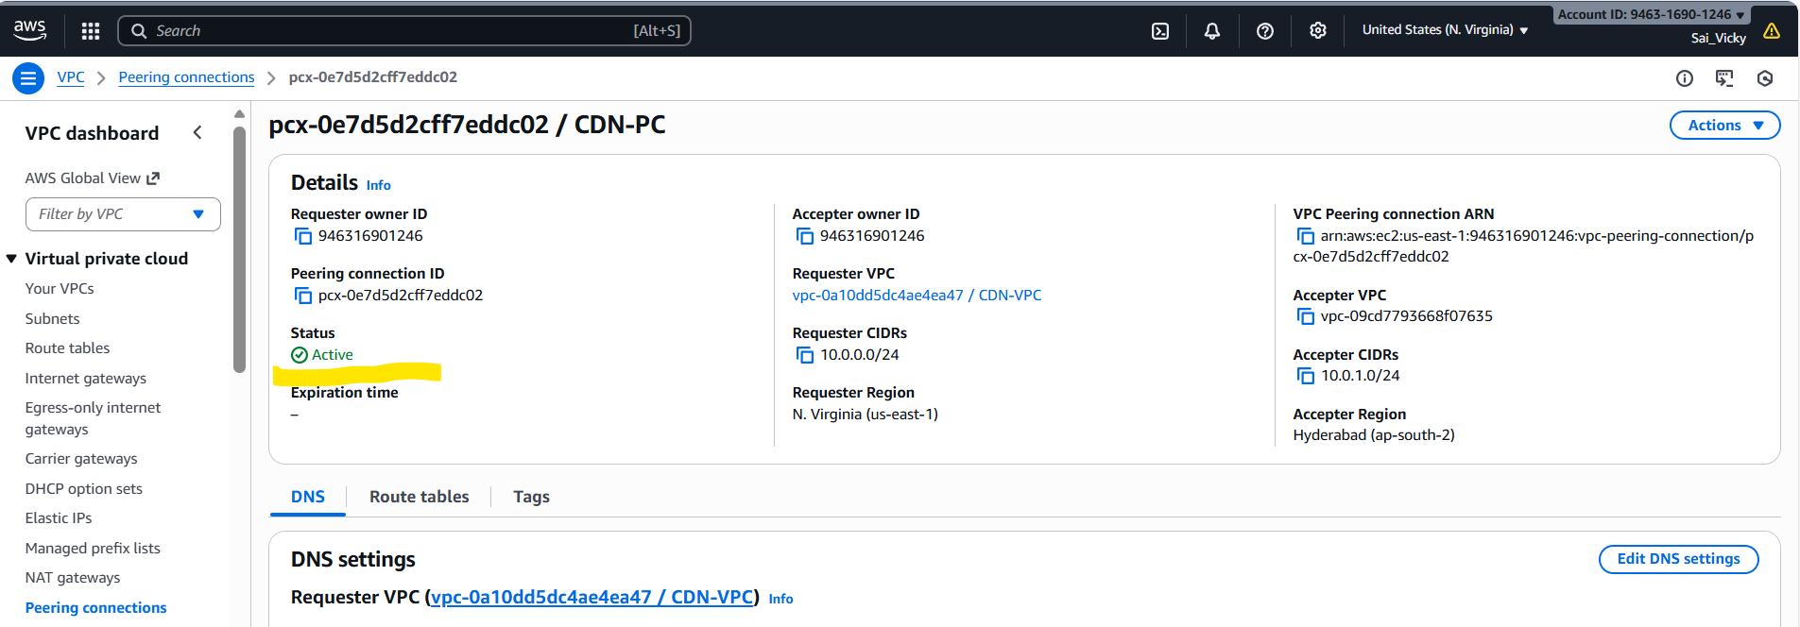

**Route tables**

Now, let’s update the **route table** of both regions vice-versa with respective **CIDR’s.**

* **N. Virginia Route table** below.

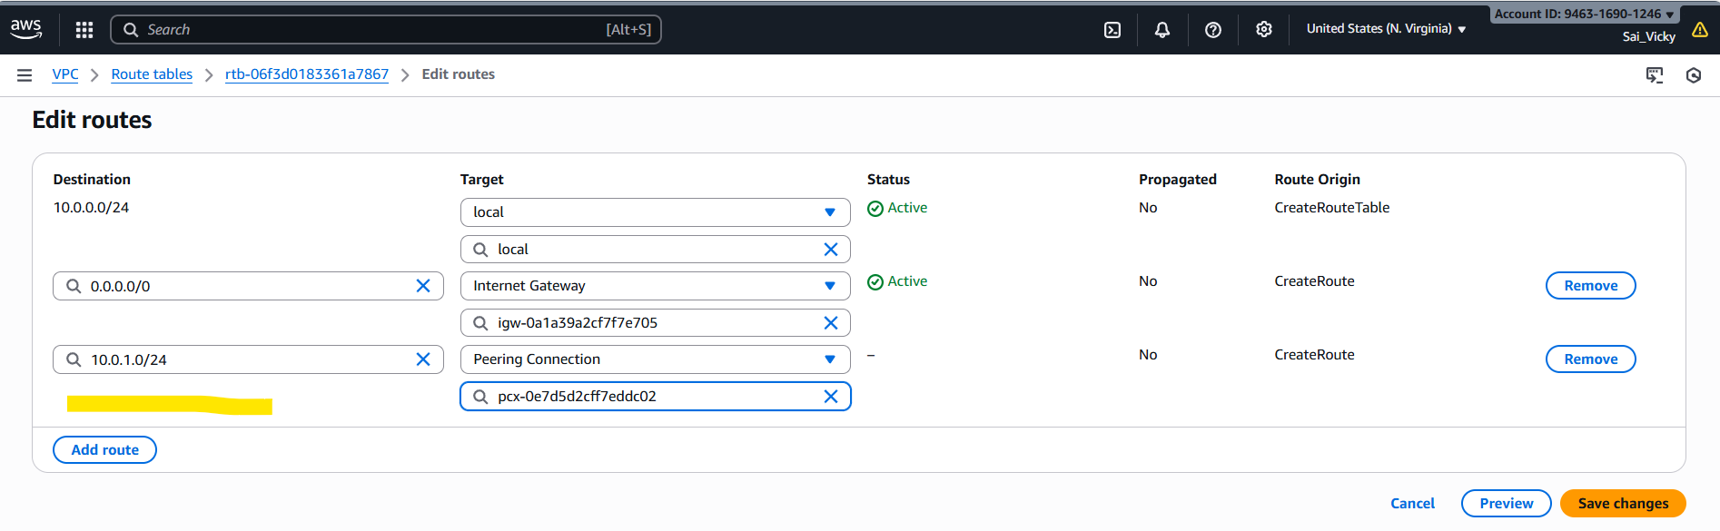

* **Hyderabad** Route table below.

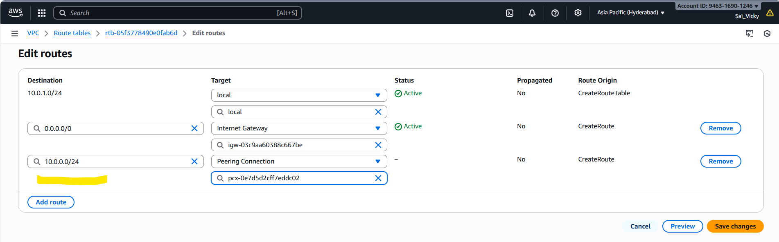

* Let’s launch a **new ec2’s** in **both regions.**
* Launching at **N. Virginia region** below.

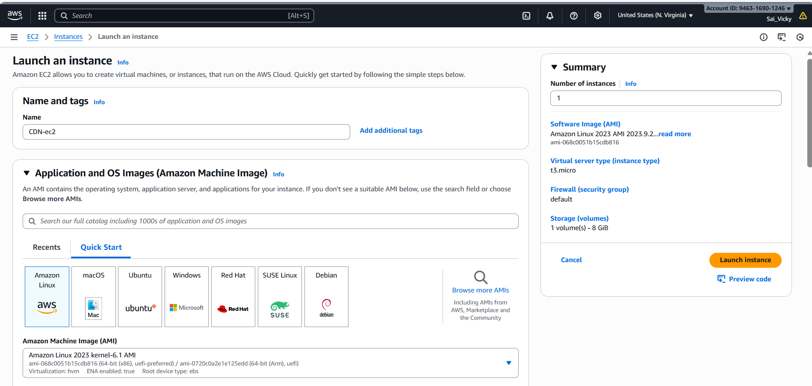

* Attached the **VPC created** and **Subnet** as well.

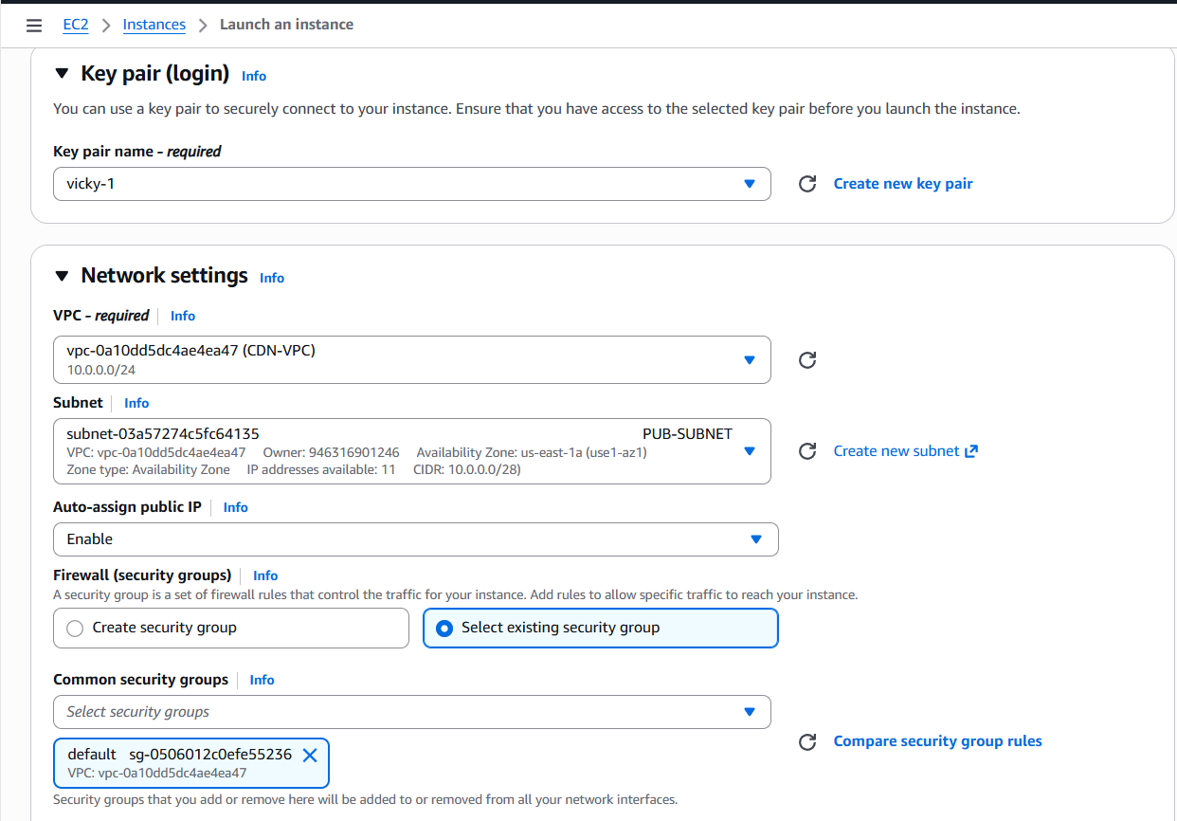

* **Instance launched below.**

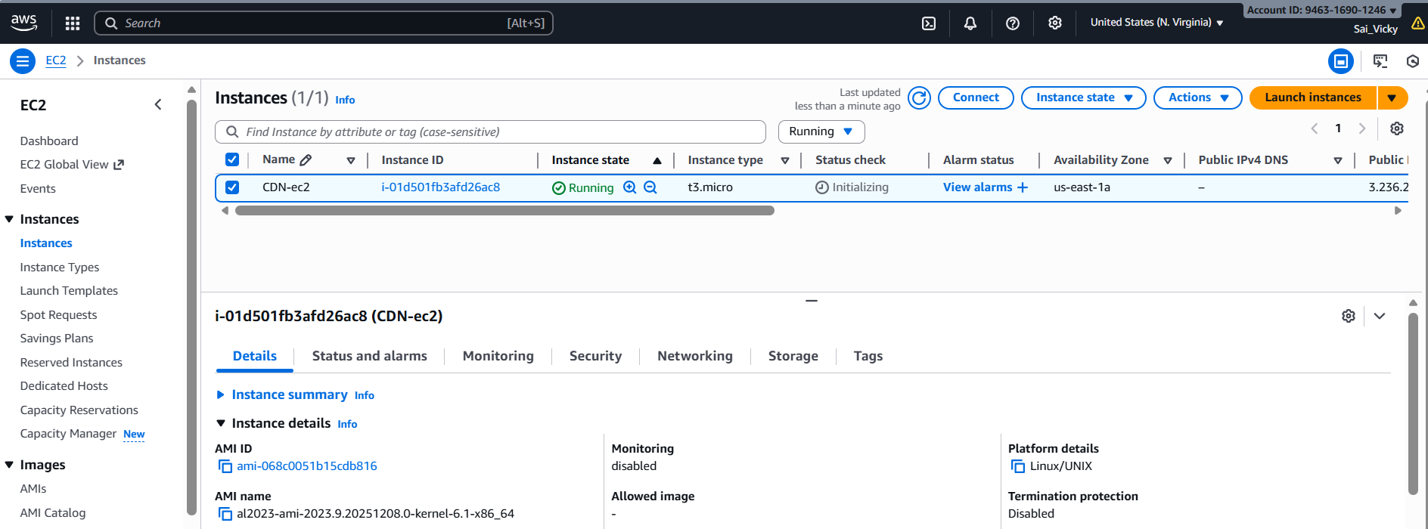

* Let’s launch the second region**- Hyderabad instance.**

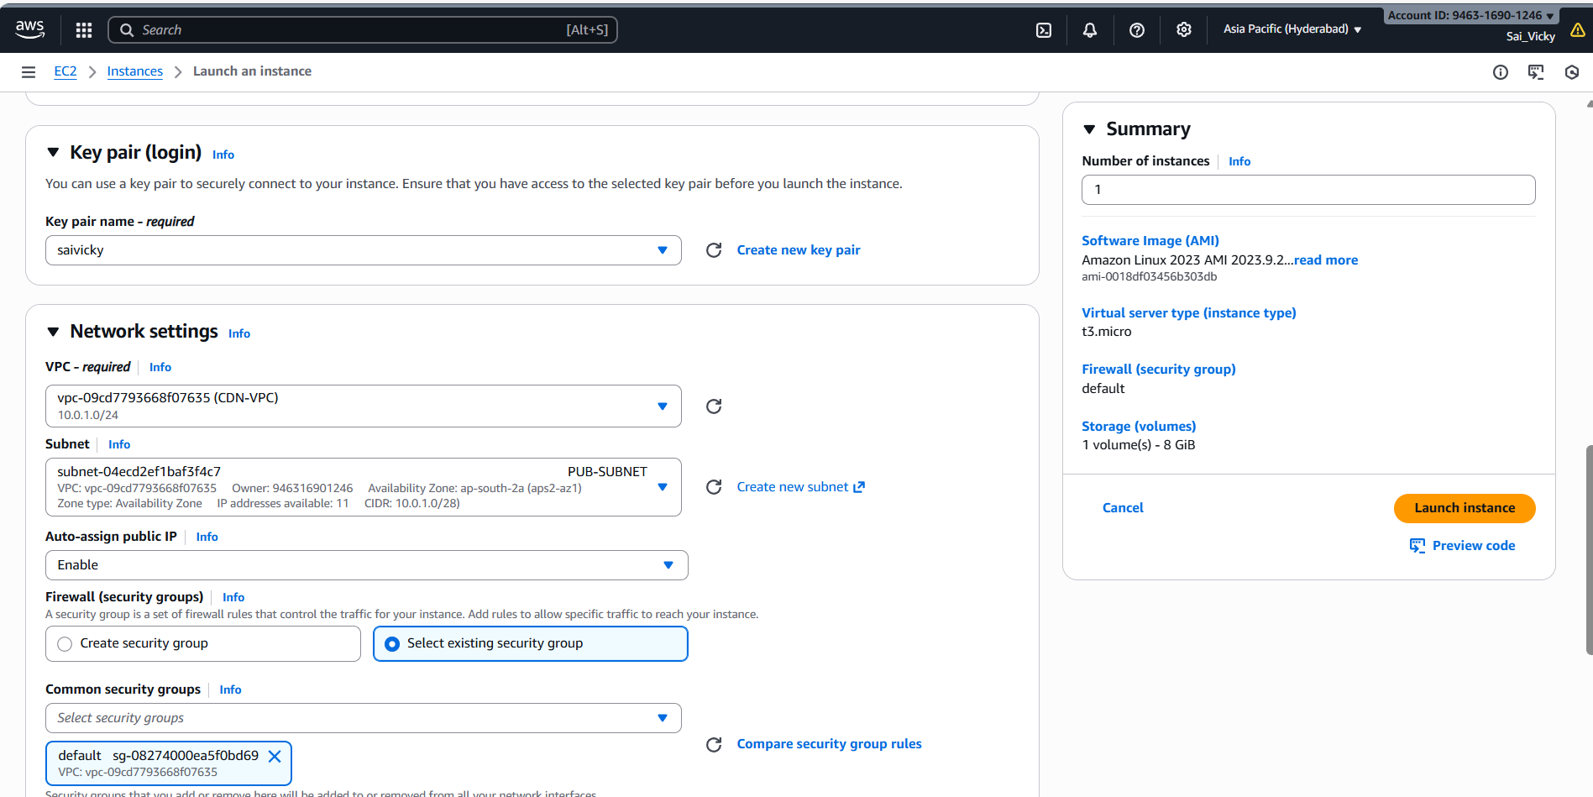

* Instance launched below for **Hyderabad region.**

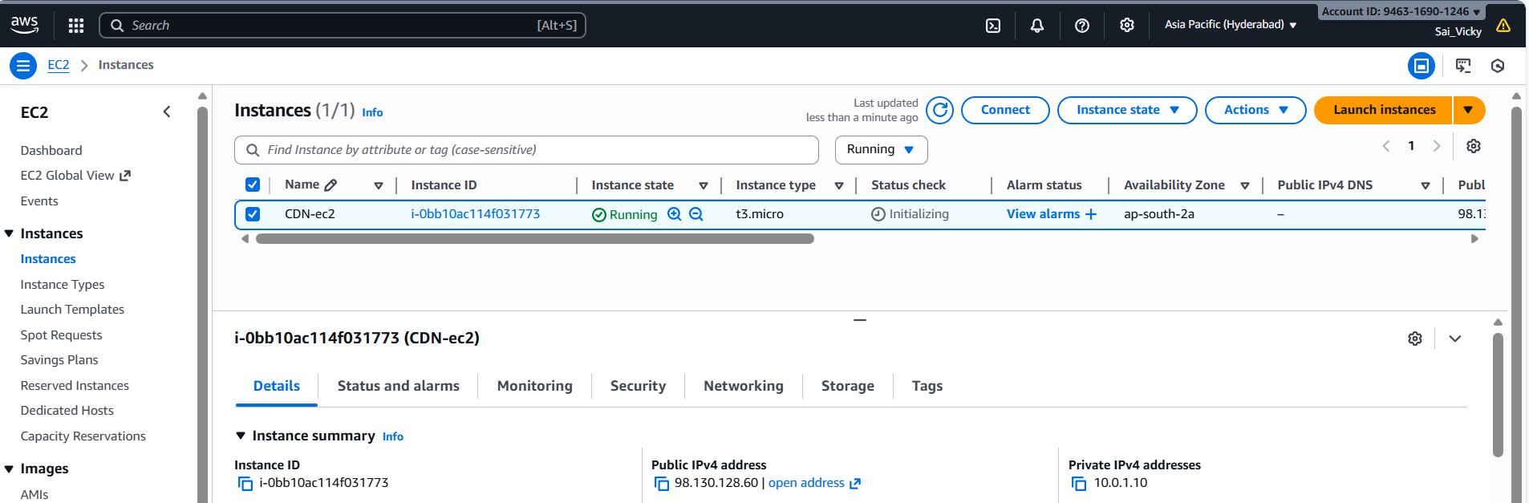

* Its time to **verify if the peering works?**
* Iam connecting from **Hyderabad ec2** and **ping N. Virginia region** using peering connection.
* **Success- Peering was successful.** We were able to **ping** both **regions.**

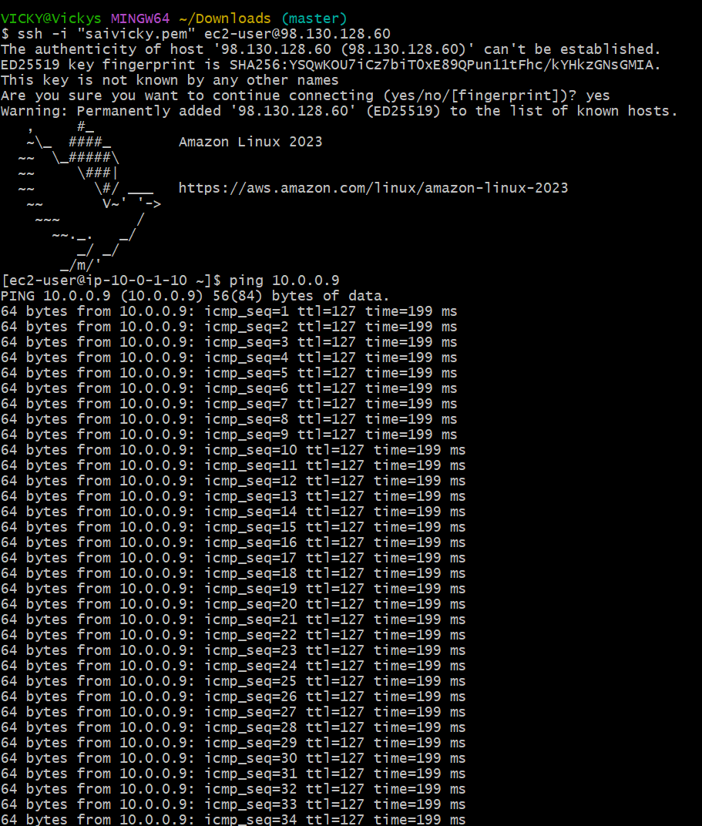

1. **Purchase one domain from GoDaddy.**

* **To purchase one domain**, we need to navigate to browser and **search for GoDaddy.**
* **GoDaddy** is a Domain provider service, where we can purchase from their website and launch our own Domain for cheaper cost.
* Alternatively, in companies, they purchase **Domain via AWS Route53.**

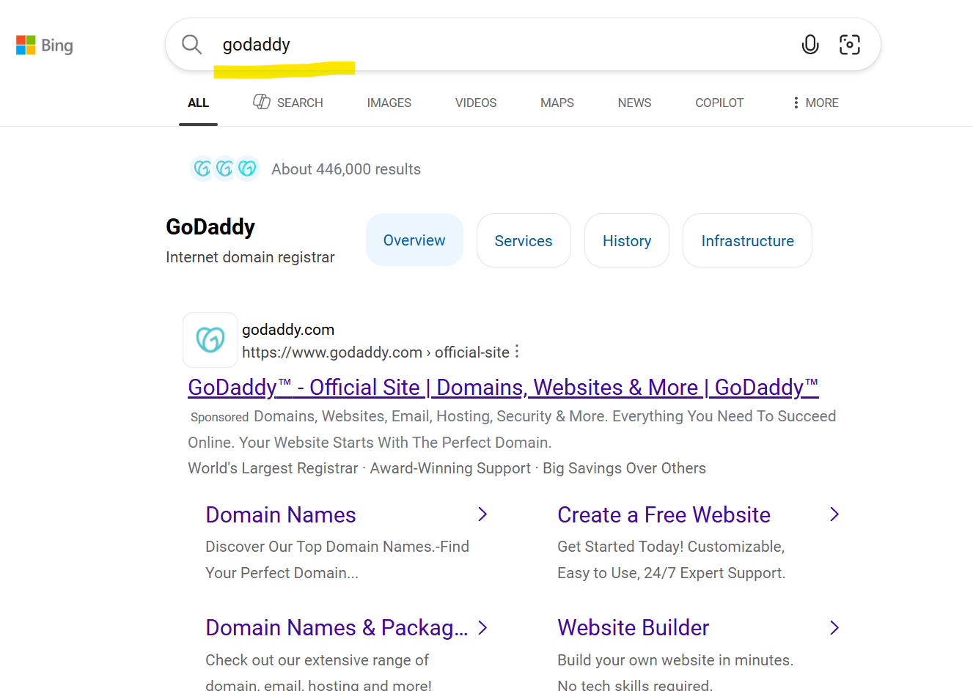

* Need to **create a new account** as we are creating for the first time.

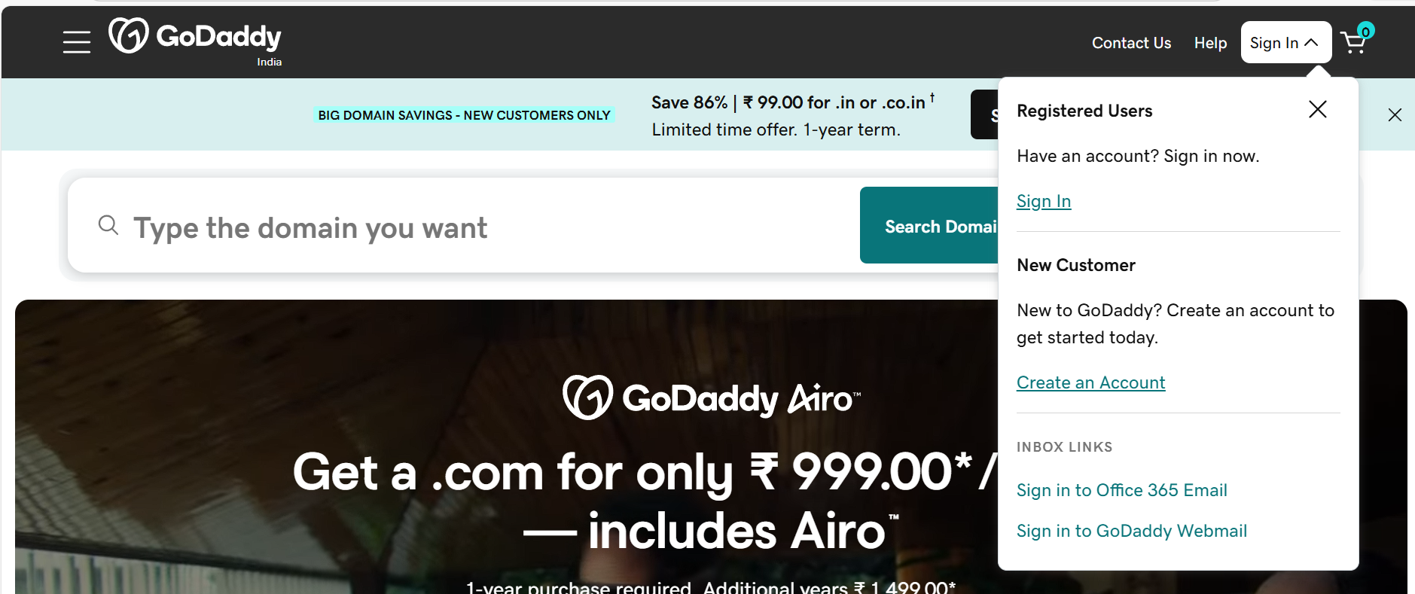

* Searched for **Vicky-DevopsEngineer.com,** but .com was pretty expensive, so looked for various options with cheaper ones.

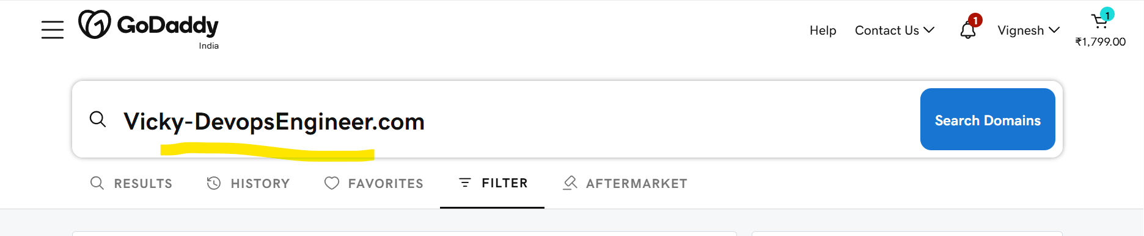

* Got a domain**- vicky- devopsengineer.online** for **89$ rupees.**

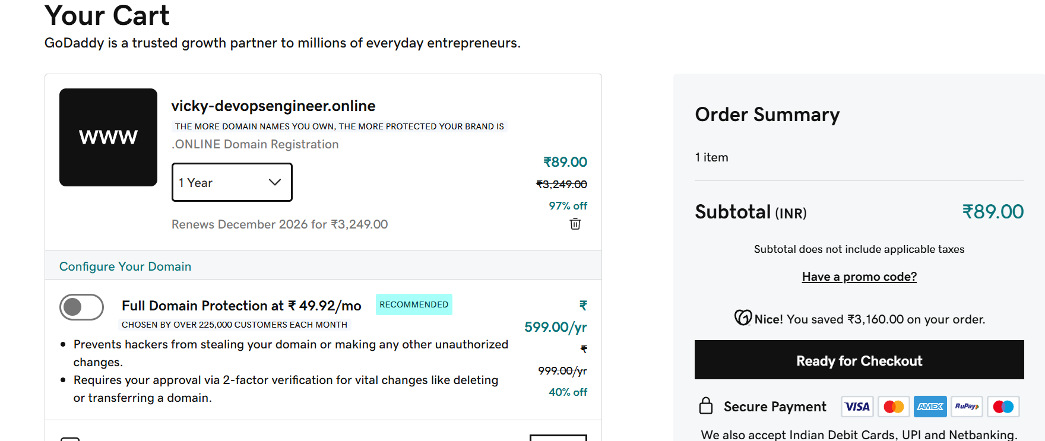

* At the checkout including taxes, got the **domain for 125$ rupees.**

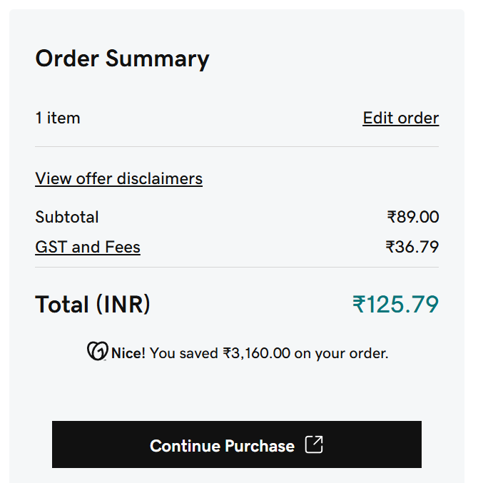

* Finally, our domain is active and we own it under the name**- vicky-devopsengineer.online**

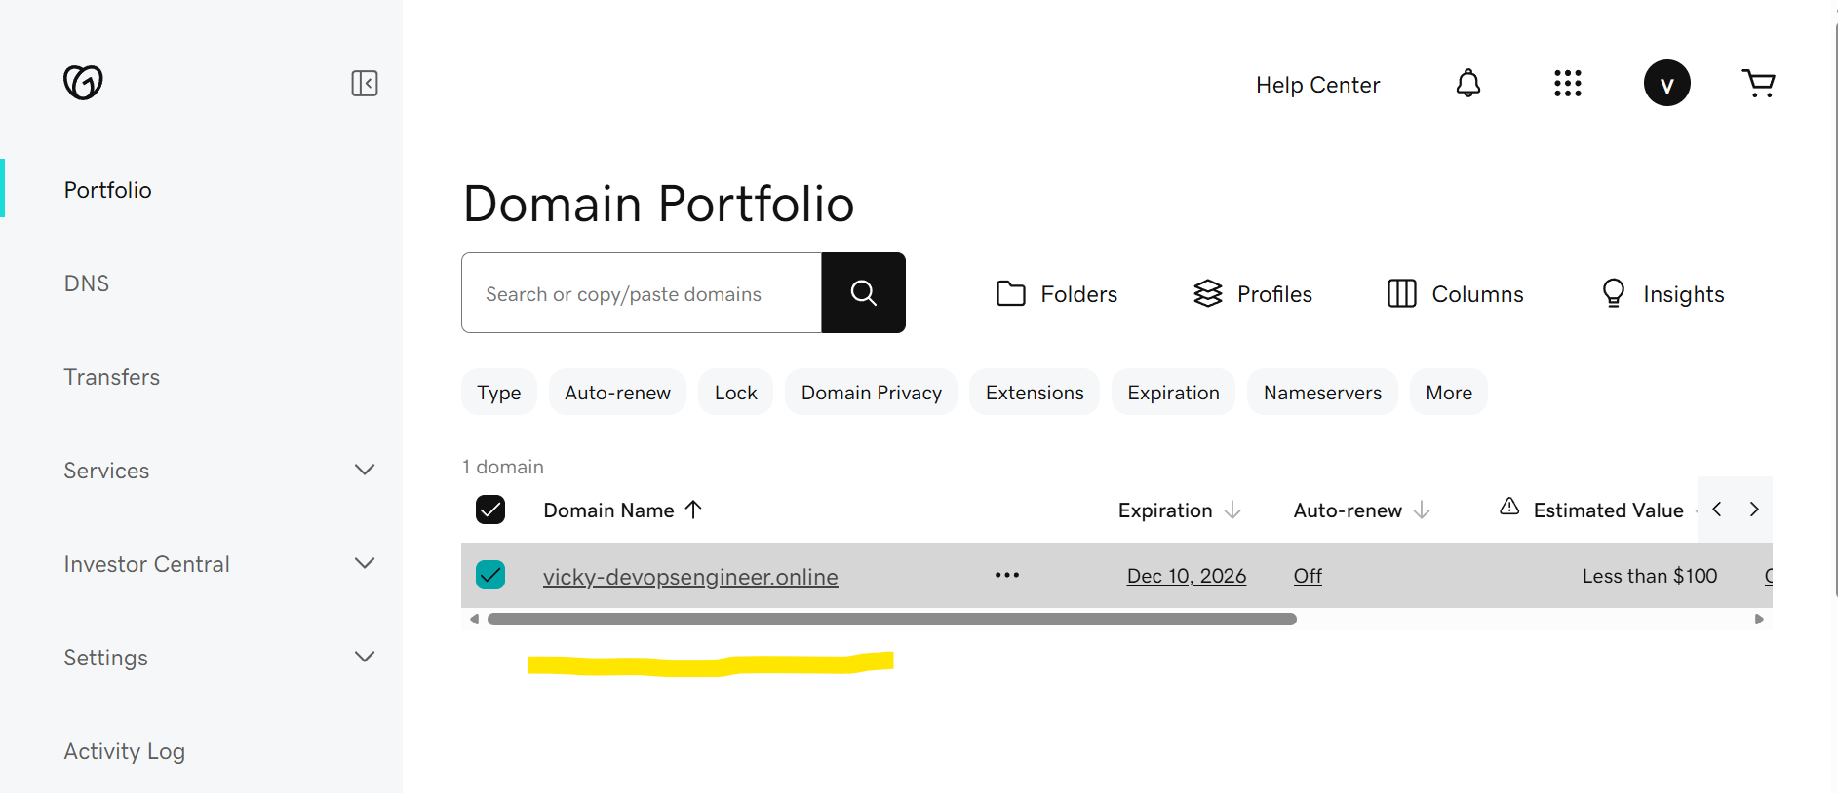

1. **Deploy static website in S3.**

* Selecting a bucket to perform this task- **vicky-root-007**

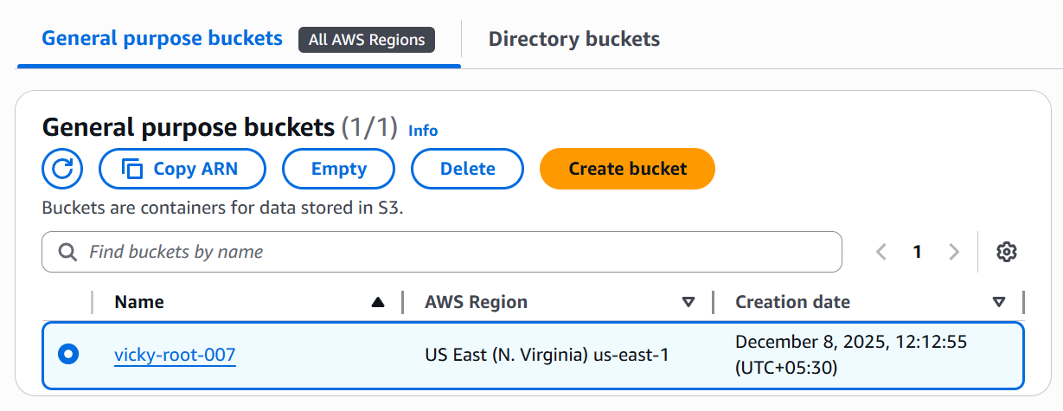

* Inside the bucket, select**- properties** and scroll down to **static website.**

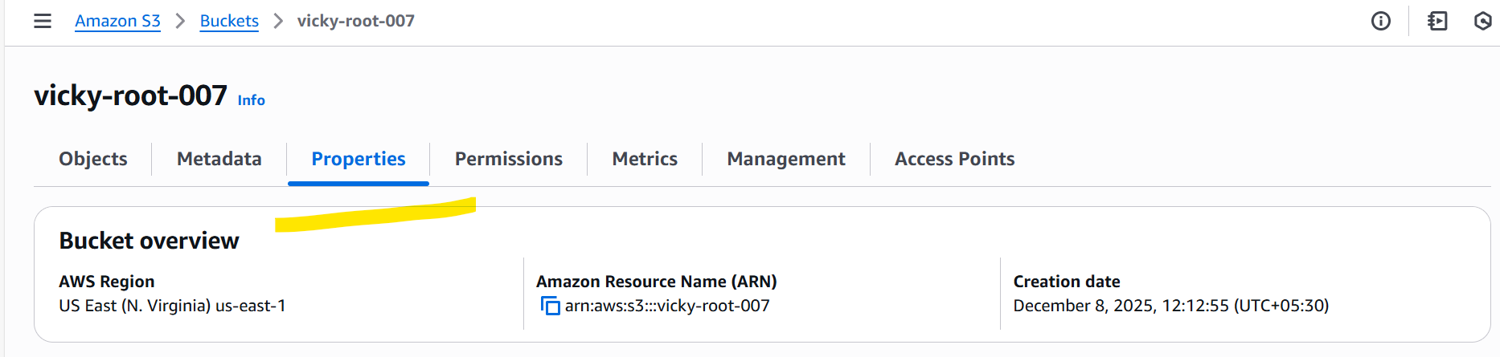

* Now **edit** the setting.

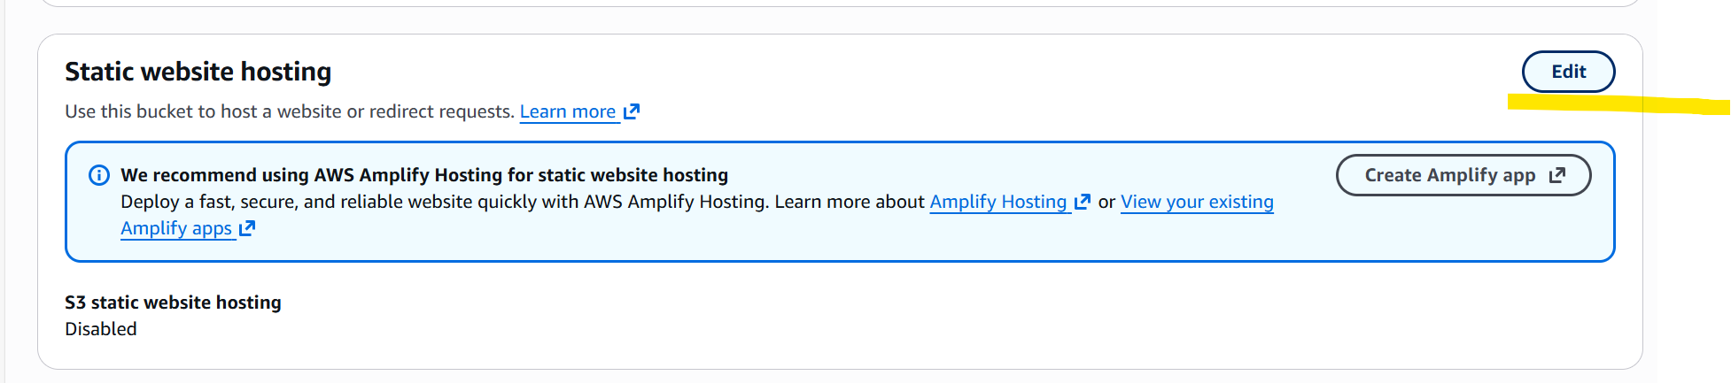

* **Enable the static website hosting**, so we can work on the folders that needs to be created

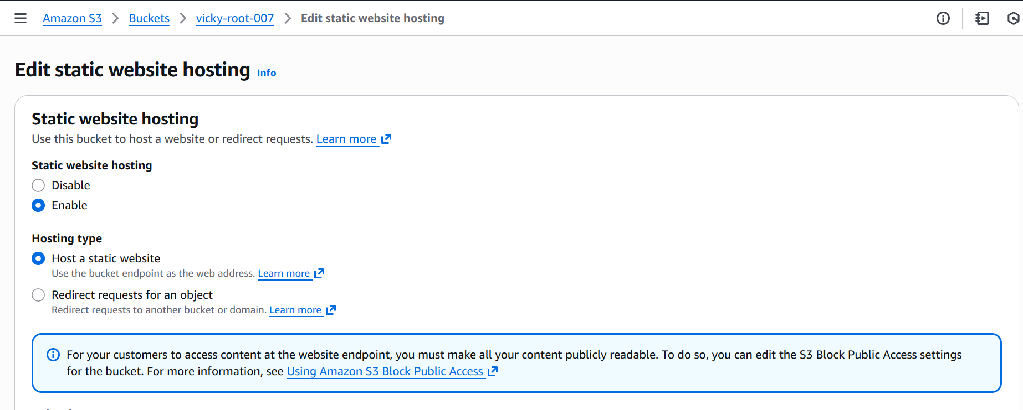

* We have named the **index document** and **error document** as **index.html** and **error.html**
* The reason for **error document** is to work when **index document** is removed or not available.
* Then save.

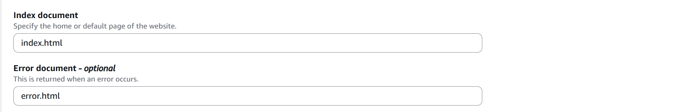

* Now the **static website hosting** requirements is complete.

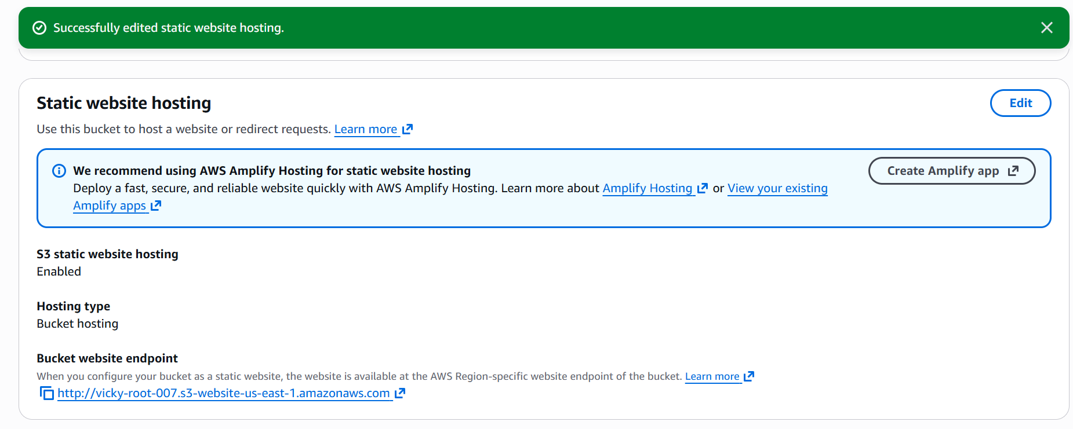

* Now, we need to create an **index file and error file** in our local Gitbash terminal
* Using **vi index.html and vi error.html**, created the content to display.

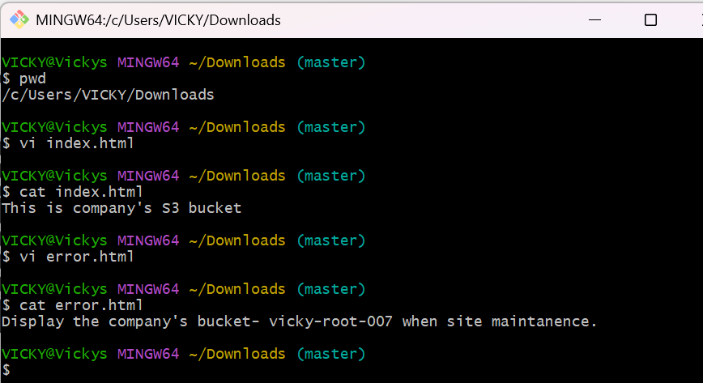

* Uploaded the **index.html and error.html** files to my bucket under**- Objects.**

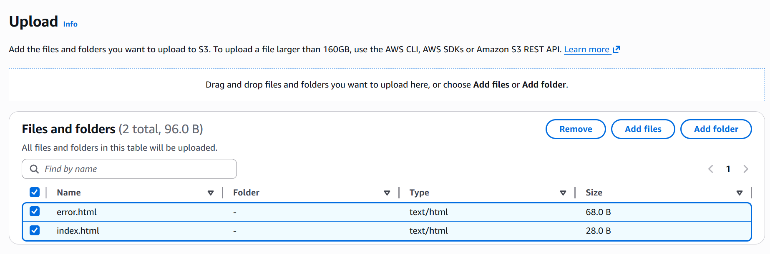

* **Successfully uploaded 2 objects to my bucket.**

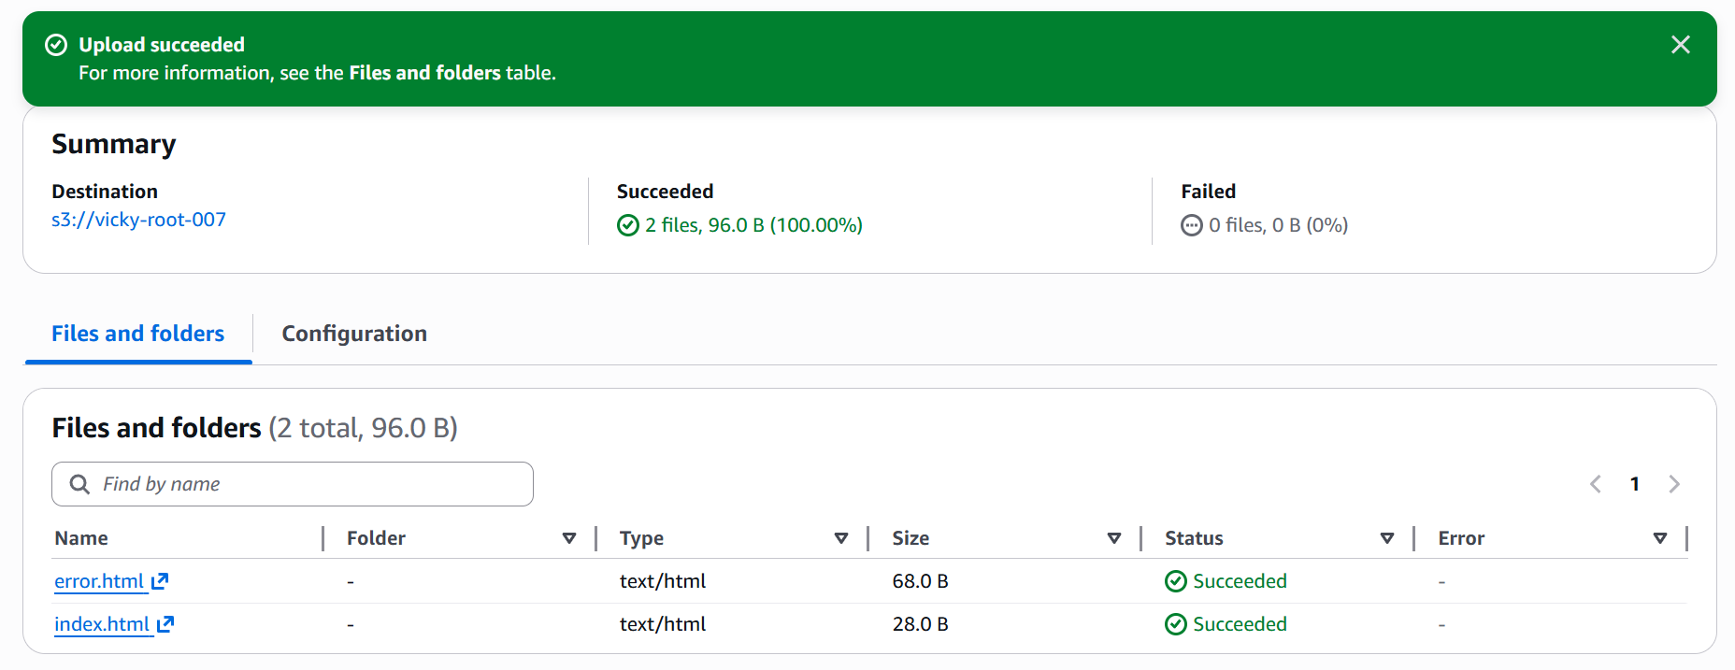

* Now, its time to **Navigate to Permissions tab** in my bucket to update bucket policy.
* To **update bucket policy**, we need to **turn off the Block access**.
* The reason for **turning it off** is to **portray my files to browser**.

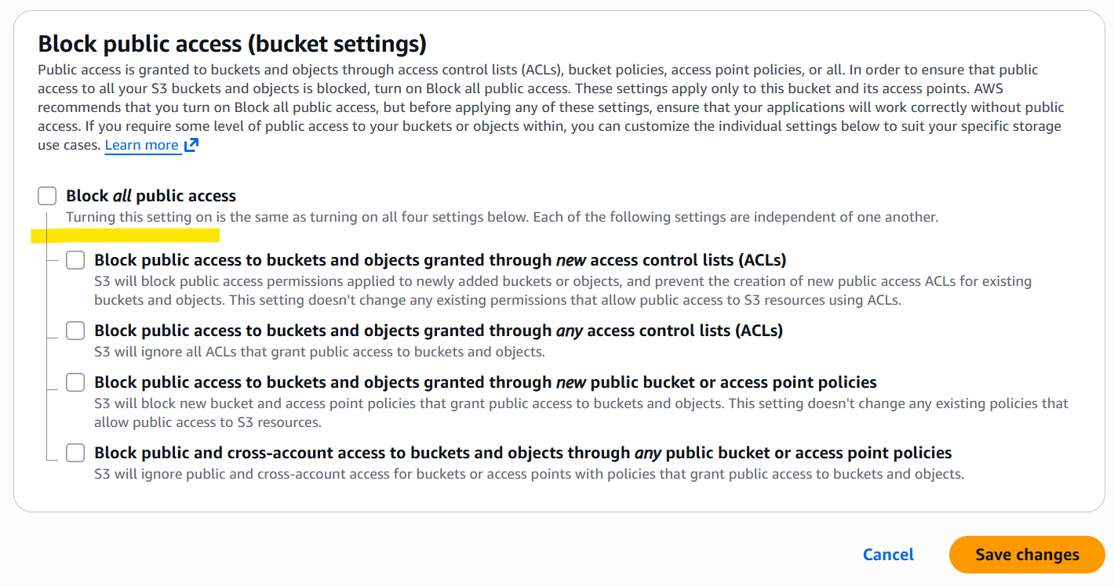

* **Under permissions tab-** uploaded a **Bucket policy** to **Public read my static website.**
* Copied the script from google and uploaded with my **bucket name- vicky-root-007.**
* **Then save.**

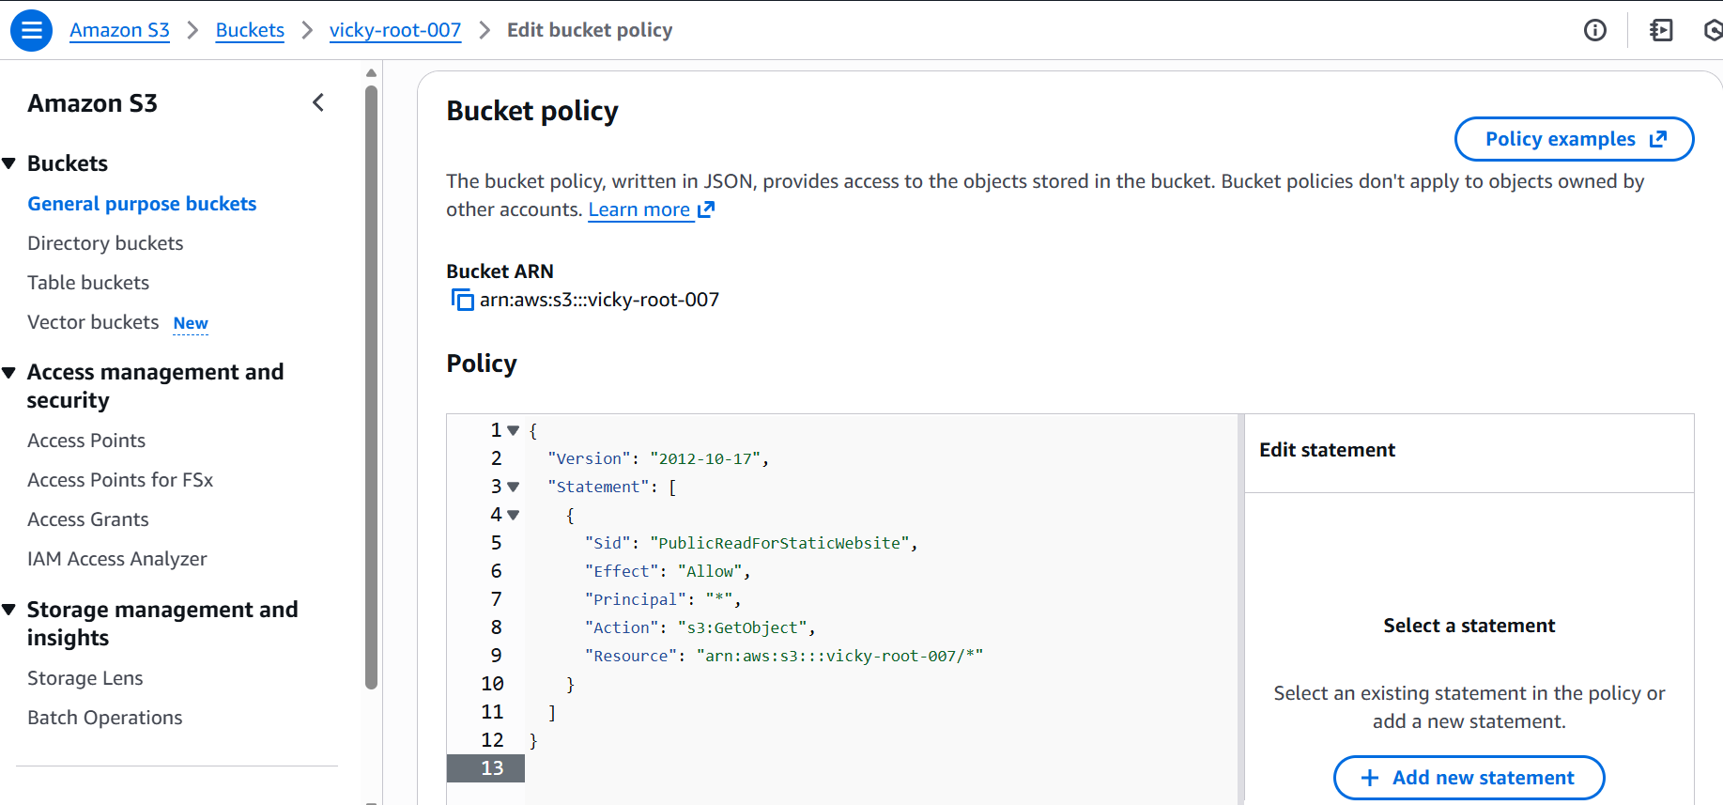

* Now, navigate to **Objects tab** in bucket and click on **index.html file.**
* **Copy the URL and paste** in the **browser for static content** to display.

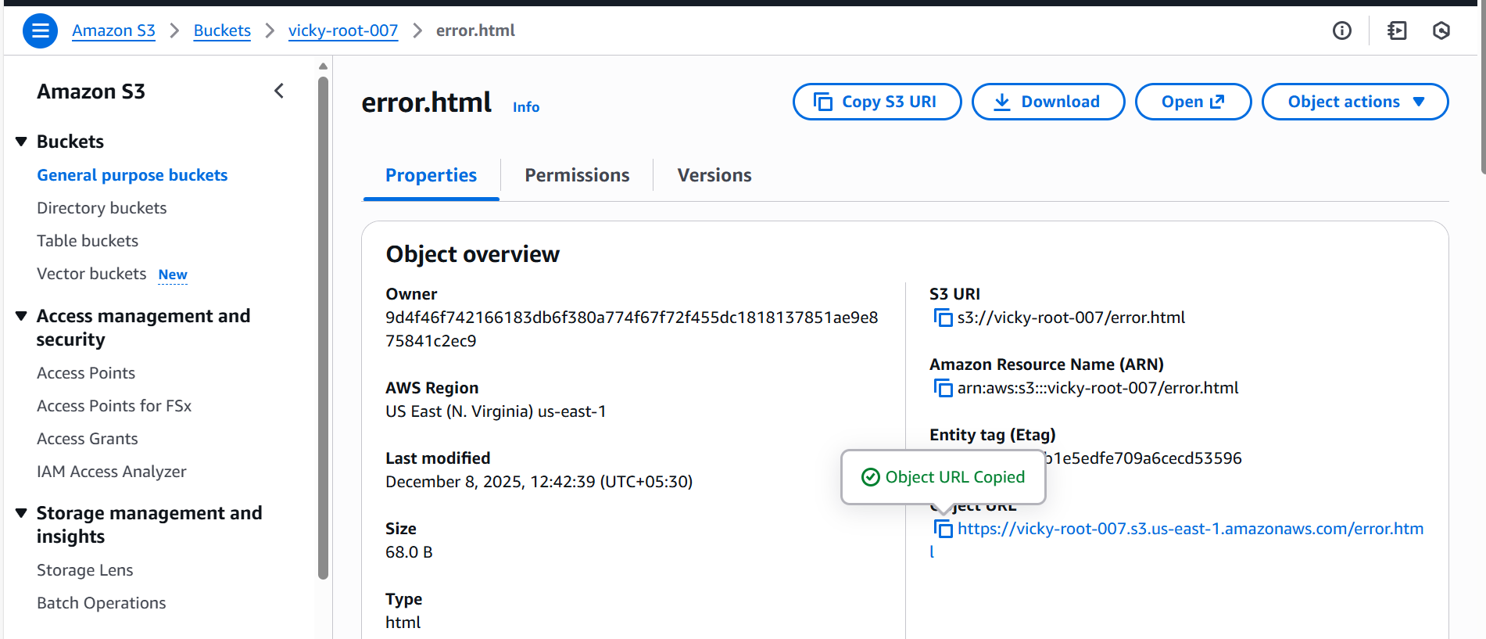

* Once the **URL is pasted in static browser**, we are able to see the content.
* Success.

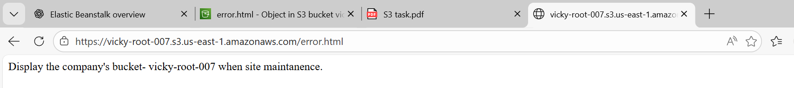

* Now, lets remove the **index file** from **objects** and verify if the **error document** portrays.
* **Success**, we can see if the **index.html file** is removed and **error.html** page is active on the **static website.**

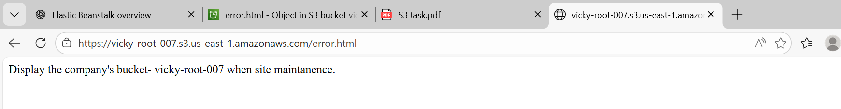

1. **Create a CDN and attach one SSL certificate.**

* **Navigate to CloudFront** and click **Create** a new one.
* **Name-** I just mentioned **Vignesh**
* **Domain-** Entered my domain name**- vicky-devopsengineer.online**

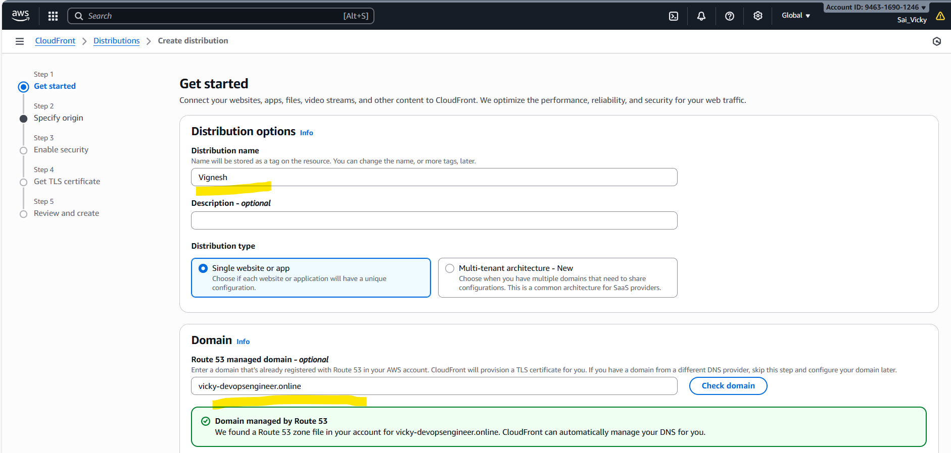

* In origin page- **Amazon S3** is our origin and while we browse the S3, our **created bucket**- **vicky-devopsengineer.online** will pop up.
* We shouldn’t always copy the same, because **website will be missing**. So, we need to **navigate to S3**, under **Properties**, 🡪 **Static website** 🡪**copy the URL and paste**.

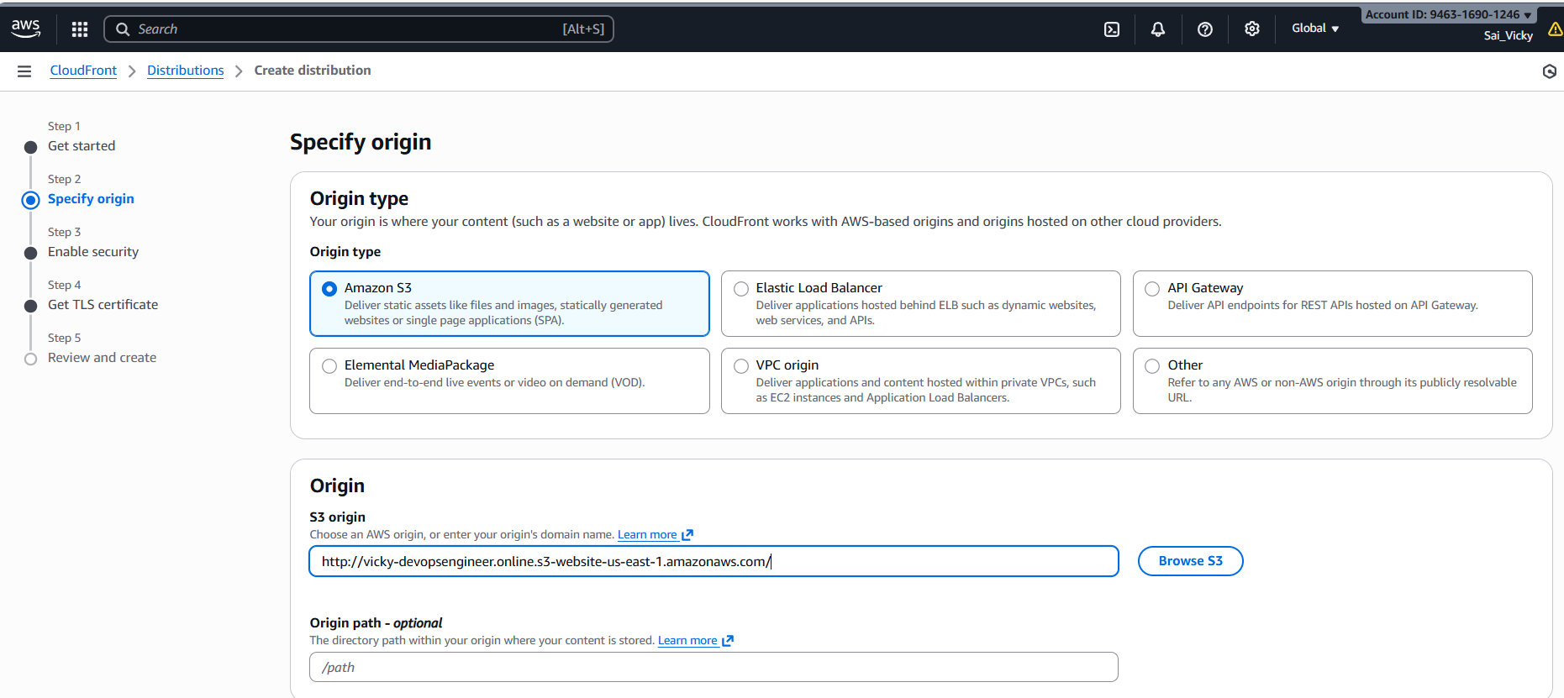

* We shall **customize** the origin settings by:
  + **Enabling the Origin Shield** and **add the region**.
  + **Protocol: HTTP only**

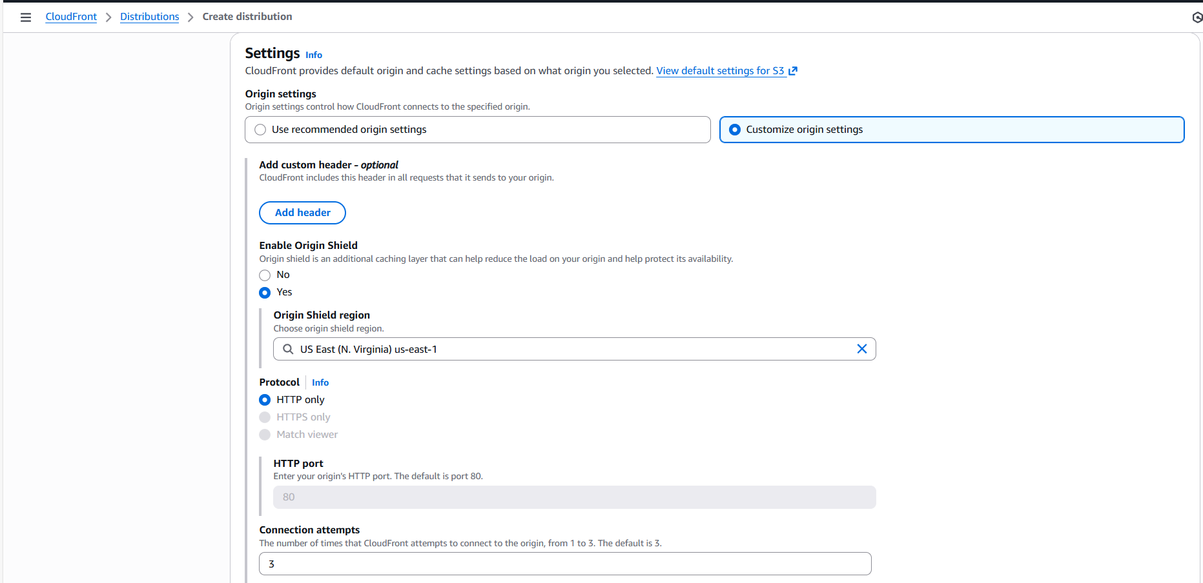

* Selected **“HTTPS** and **HTTPS”**
* Rest is default.

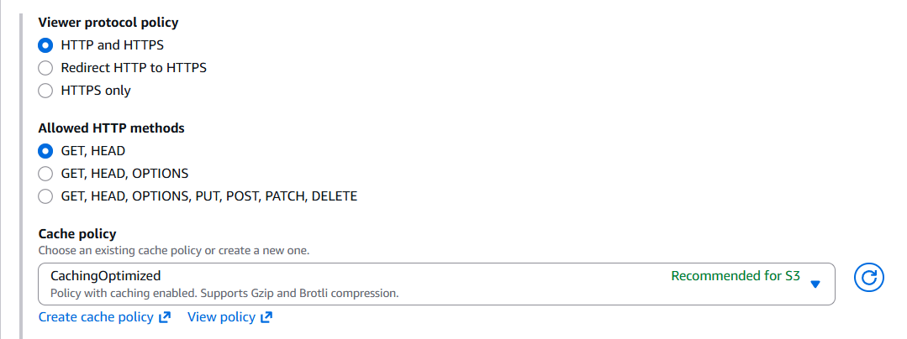

* For now, we are not enabling the security **firewall.**

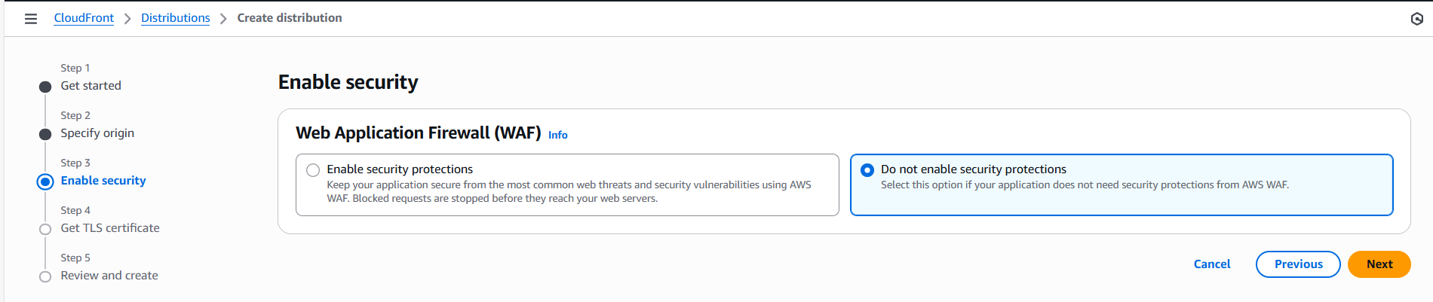

* By navigating to the **“Create certificate in ACM”,** we will be able to get the **SSL certificate.**

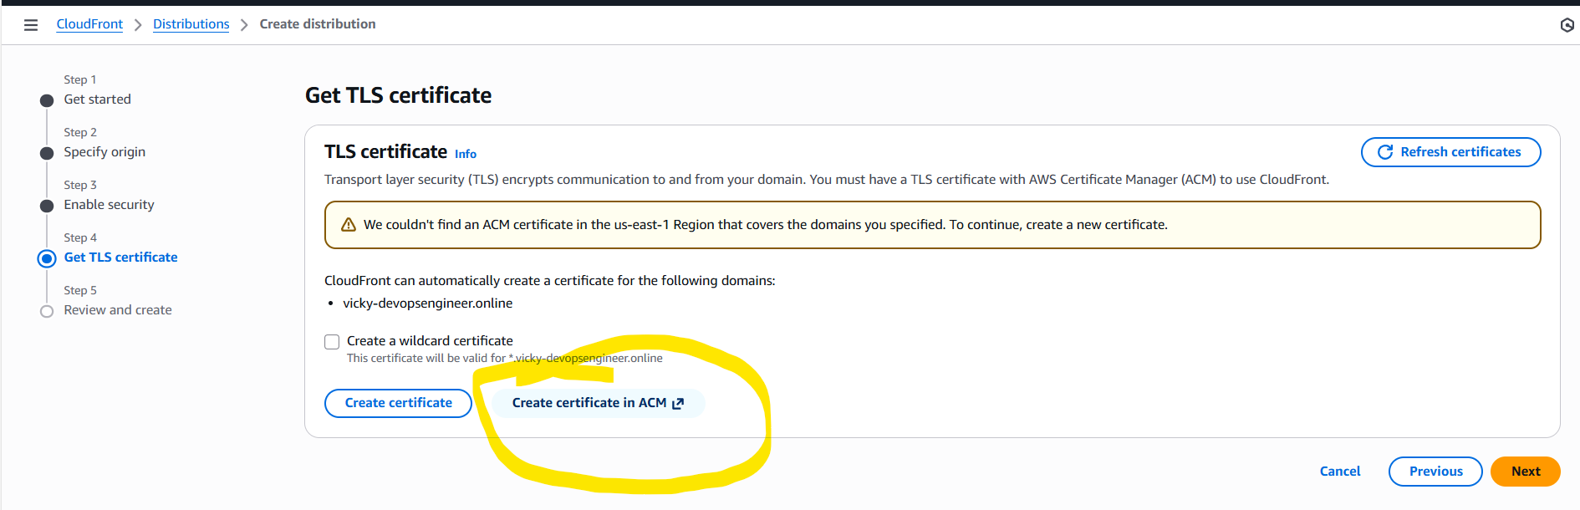

* We just **skipped adding the certificate for now** and creating the **distribution.**

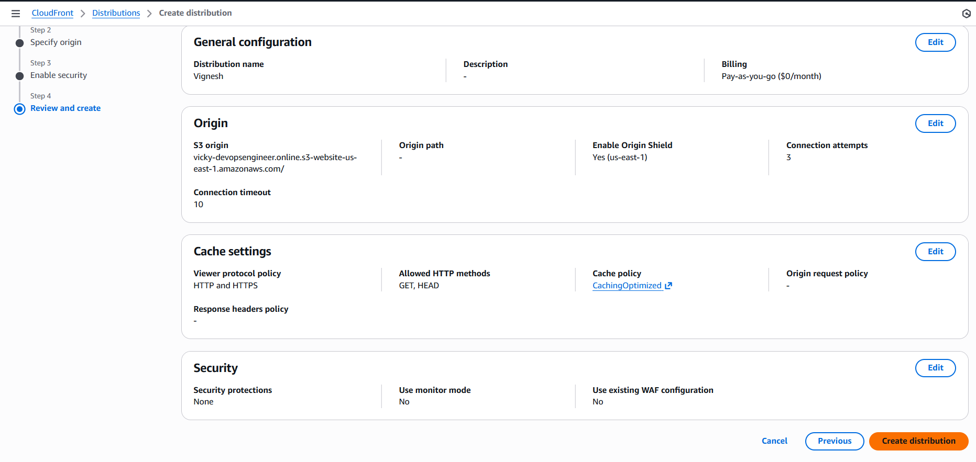

* Finally, my **distribution** is created in **CloudFront.**

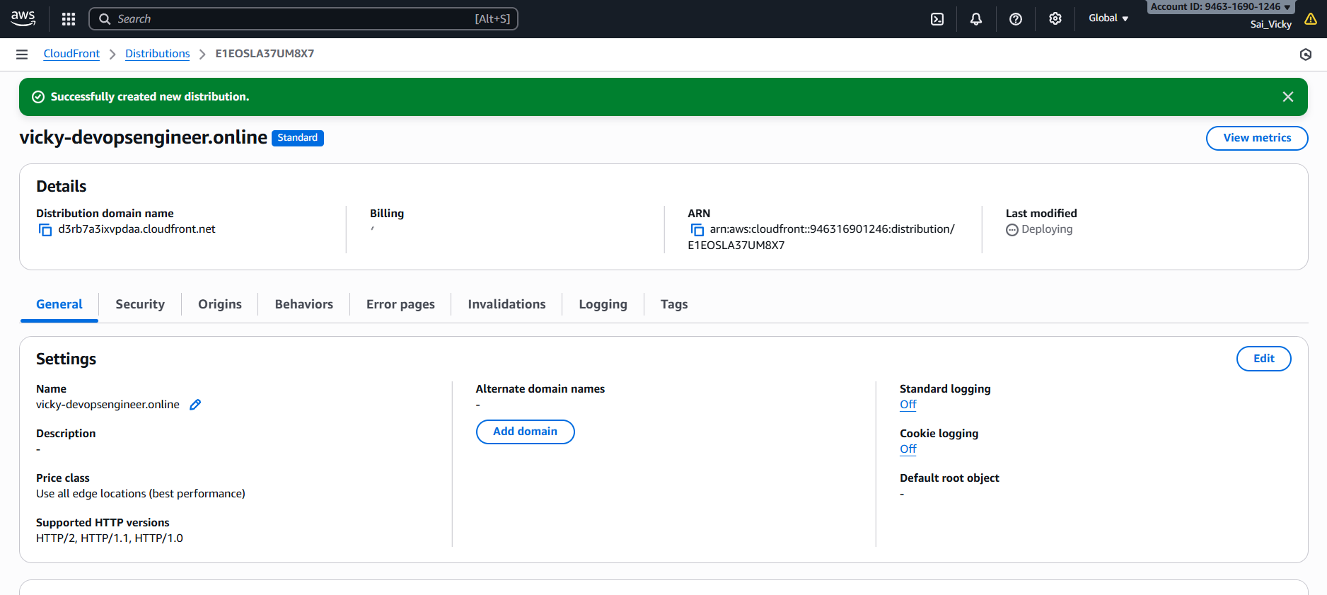

* If I need to verify if my **static website is working**, then I can confirm from my cloud watch **(Distribution domain name)**- **d3rb7a3ixvpdaa.cloudfront.net**
* **Success-** We have attached **SSL certificate** to my **CloudFront.**

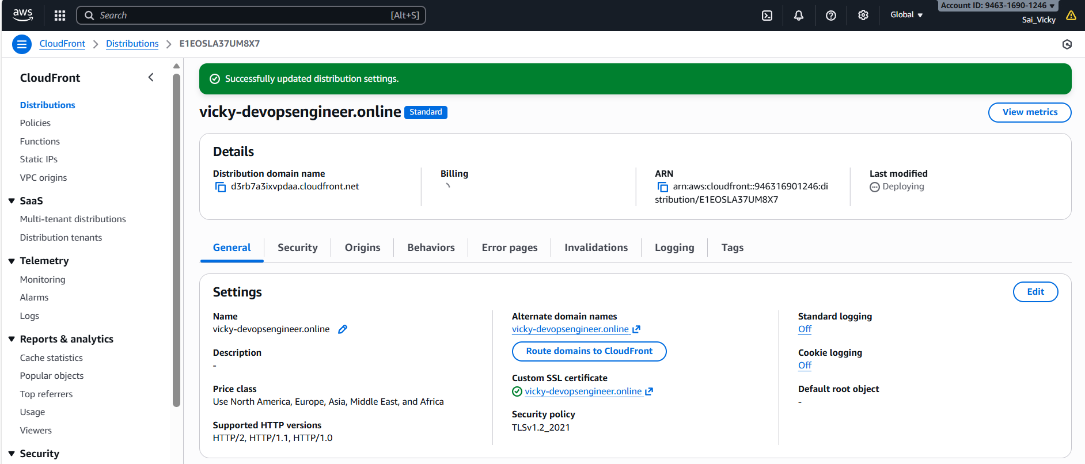

1. **Create a Route 53 hosted zone and map the domain with the CDN.**

* We have our Domain created in **GoDaddy** and hosting zone will be in **AWS Route53.**
* First, let’s navigate to **Route53** in **AWS** and select **“Create hosted zones”**

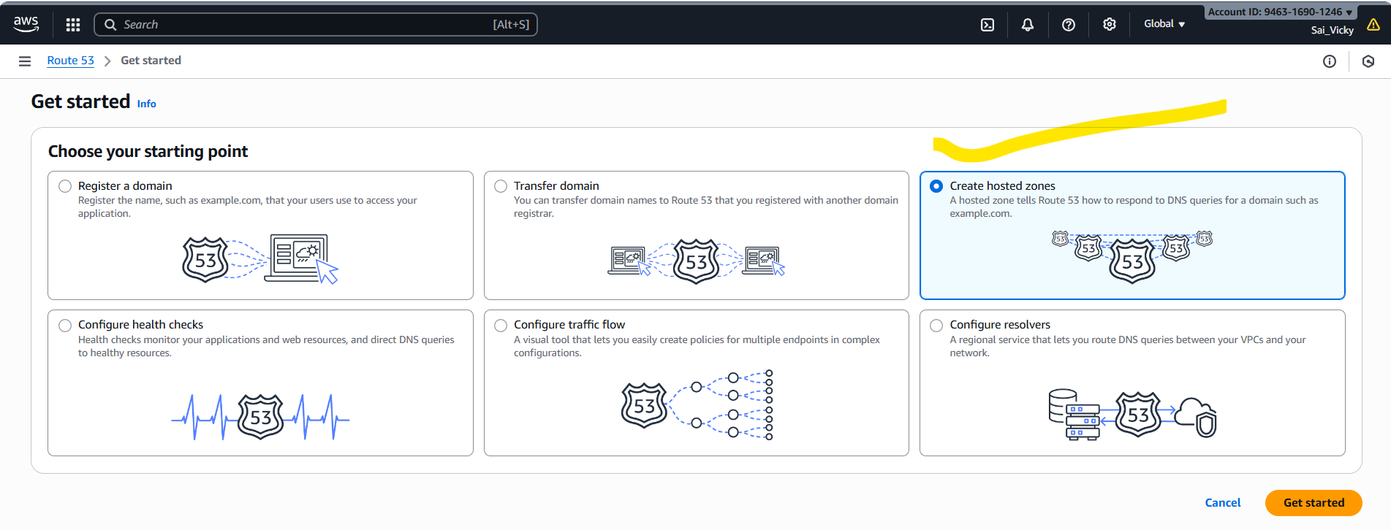

* Now, let’s **enter the domain name** which we created in **GoDaddy** and select type as “**Public hosted zone**”.

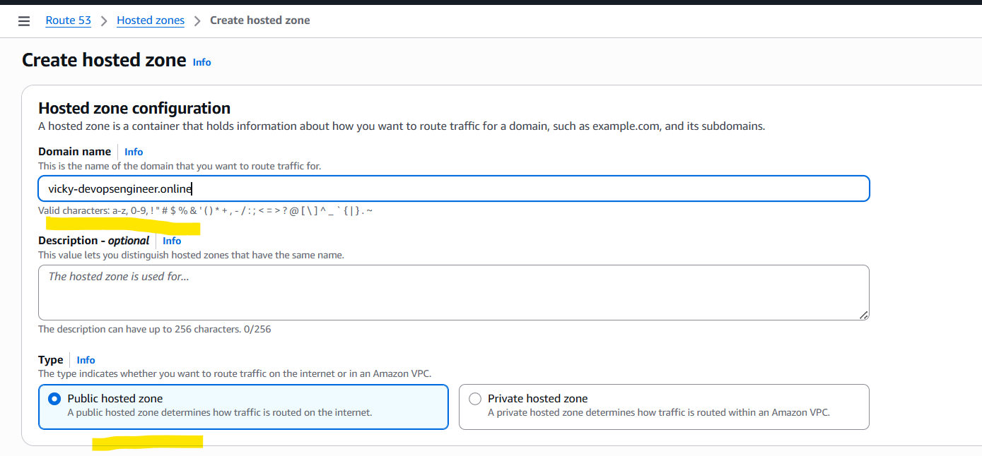

* Now, we have hosted the zone in **route53** and have the **Name server** and **Security of Authority** values generated.

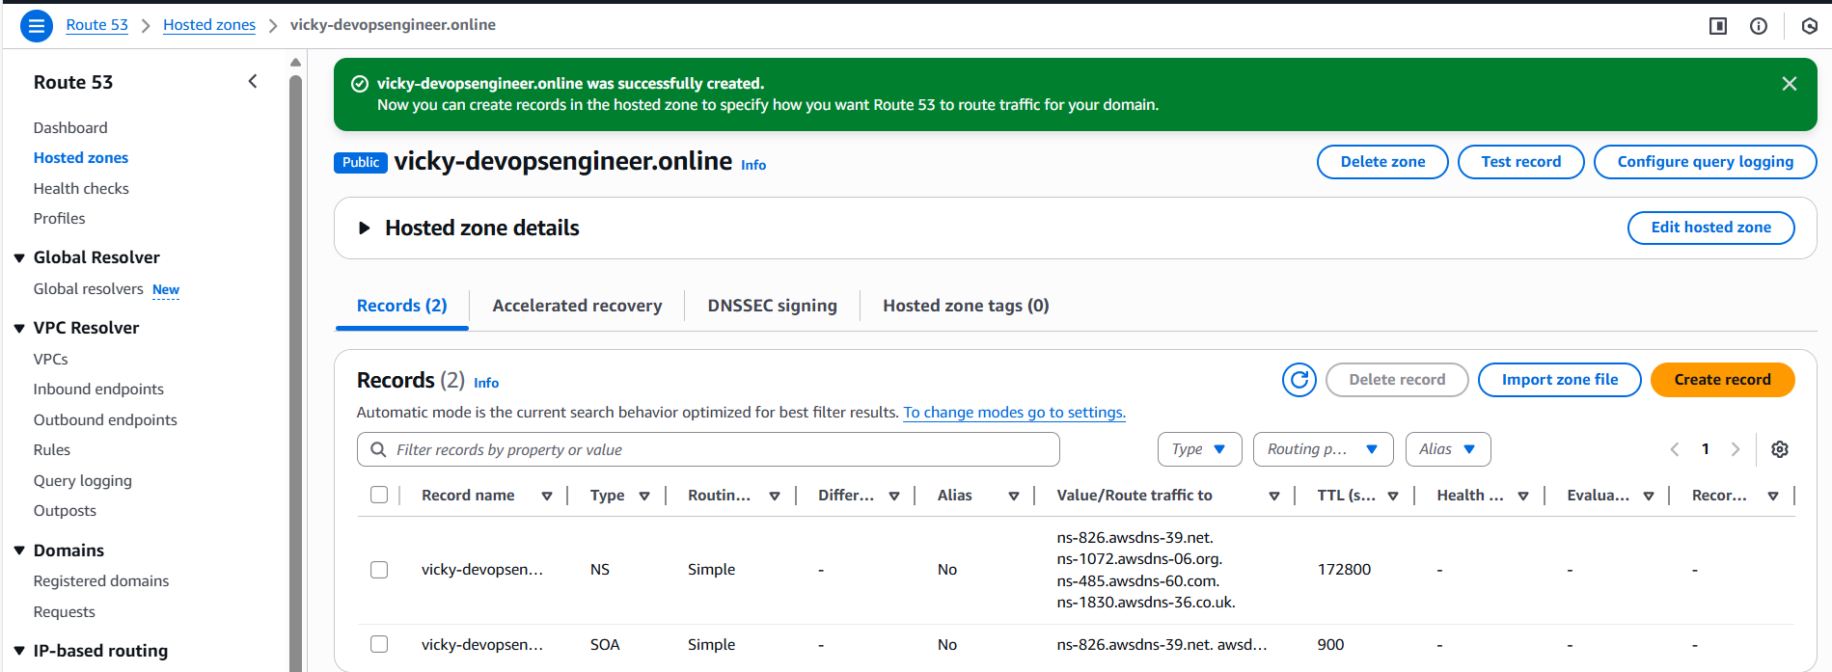

* We have generated the **Name server** values and copied over here below.
  + **ns-826.awsdns-39.net**
  + **ns-1072.awsdns-06.org**
  + **ns-485.awsdns-60.com**
  + **ns-1830.awsdns-36.co.uk**
* These **NS values** need to be copied over to **GoDaddy website** and paste it under **DNS.**

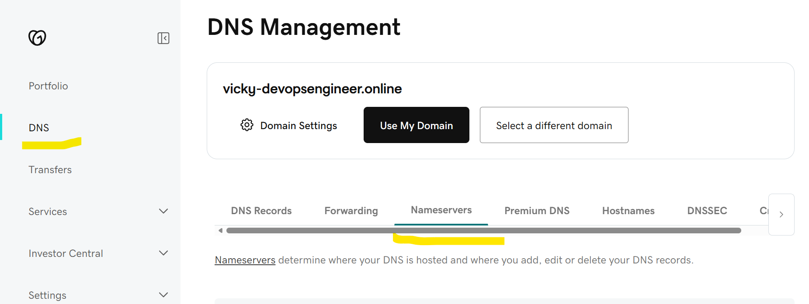

* The **NS values** has pasted in **GoDaddy DNS** and hit **save**.

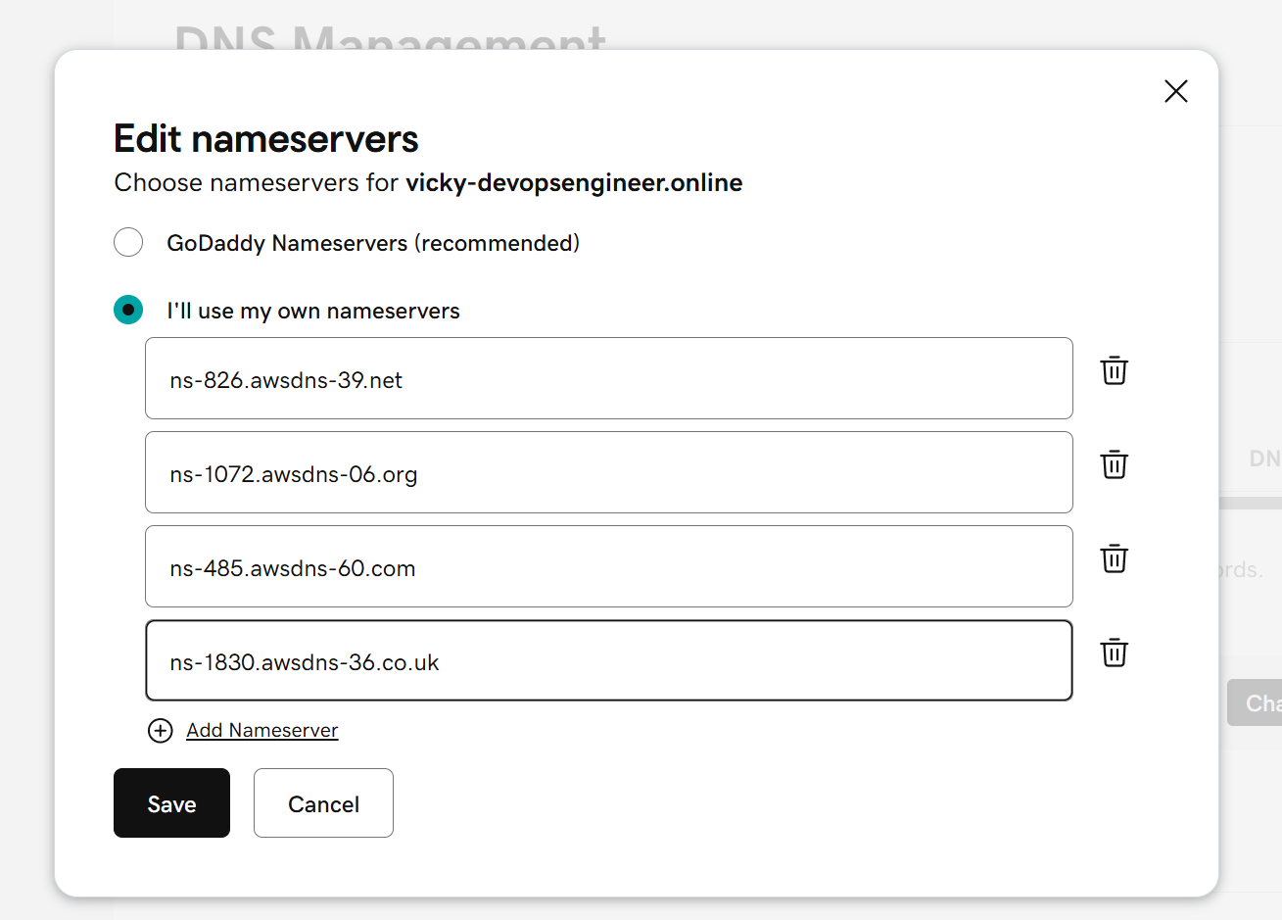

Below, we can see the **NS values** have been added to **DNS- Domian Name Server**.

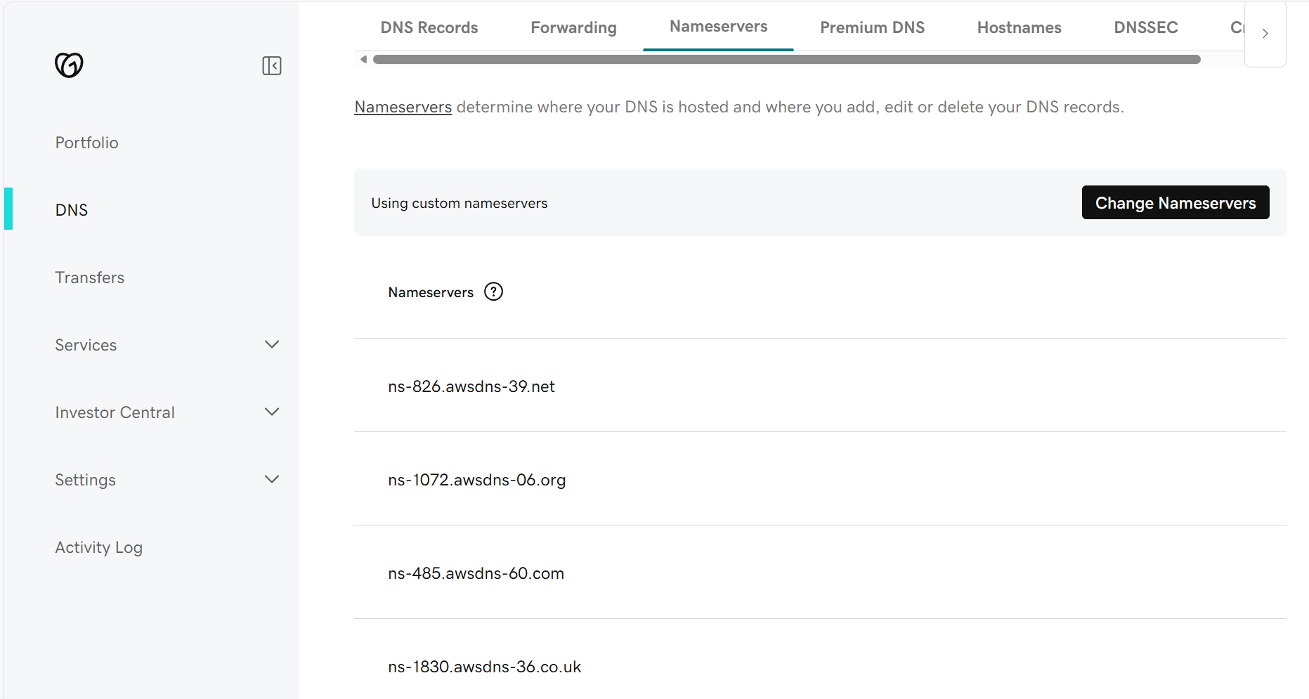

* **In the previous task- we created CloudFront and attached SSL certificate.**
* **Now, we need to perform the DNS routing.**
* Navigate to **CloudFront 🡪**Under **General Tab 🡪Route domains to CloudFront.**

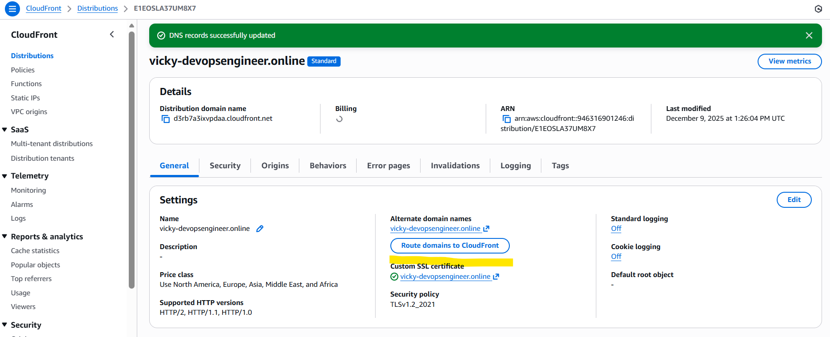

* This is our **R53** showing **DNS routing** is successful.

1. **Update the index.html in the S3 bucket and ensure the updated file is accessible using the domain name.**

* Navigated to downloads where the **index.html is present** and updated the file using my requirements.
* Once deleted the file in s3 and updated my file. My domain name opens with my updated content in index.html.

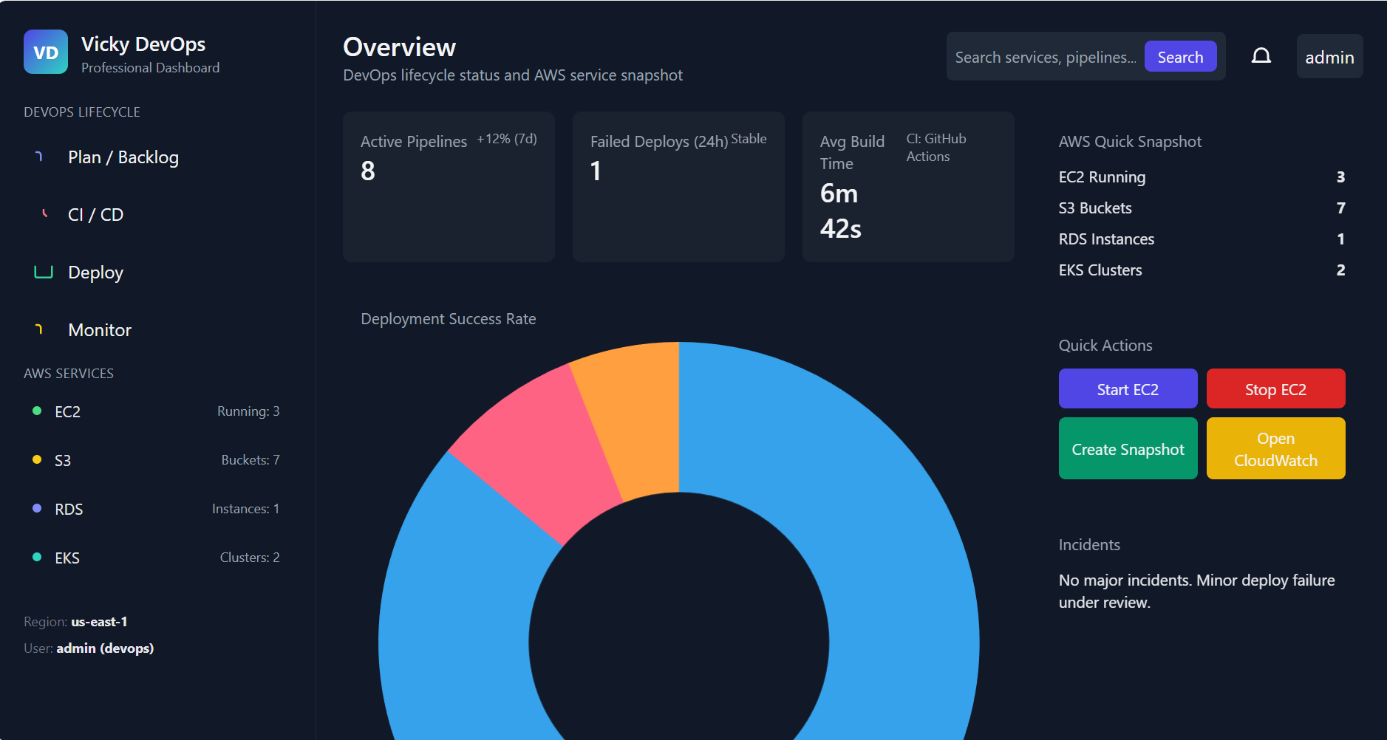

1. **Share the domain name in Slack to test the connectivity.**

* Domain- **vicky-devopsengineer.online**

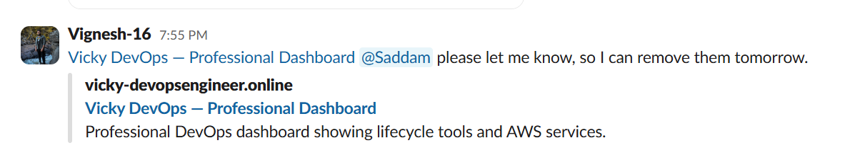

* **Issues faced/ Error document**-
  + For the **1st question- VPC Peering**?
  + All the process was completed, yet, I couldn’t get connected to ec2 instance, because, I did not update the security groups to all **“All traffic”.**

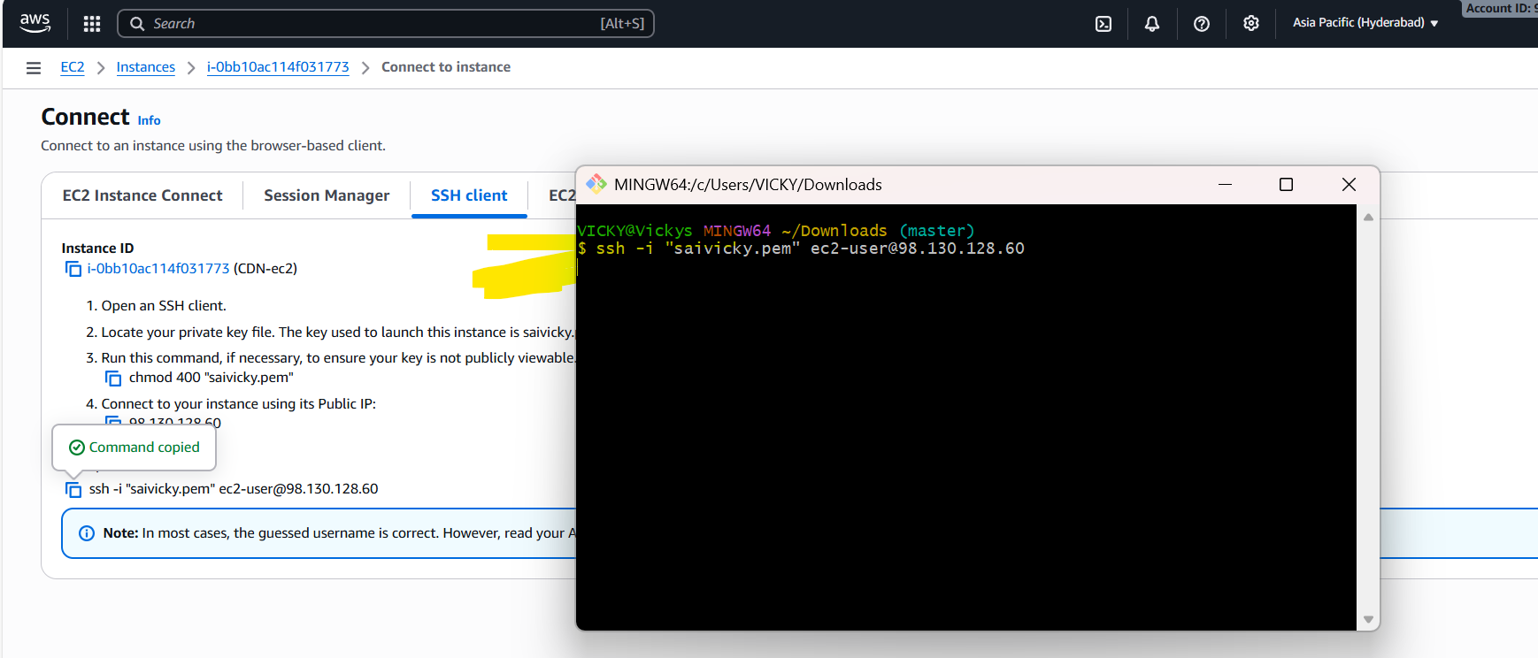

* + Provided all traffic to **SG** in both regions and its working as expected and I was able to ping the other region.
* **Conclusion**: CloudFront is important topic to provide secure static website hosting.